ETHICAL SOFTWARE Community
Fedora Linux Introduction

Table of contents

Fedora Basic 1
Installing Fedora! 2
Installing Rpm Fusion (DNF) 20
1. Enabling the RPM Fusion repositories using command-line utilities 20
Installing Rpm Dependency/Packages (Yum) 24
Easiest apps Installation from “Software” (App store) 30
How to Search and Install through DNF (Terminal) 33
Updating Fedora 39
Terminal Basic 1
Basic Commands 2

Fedora Basic
Here are the basic things you need to know about Fedora Linux.

Installing Fedora!
READ THE FOLLOWING REMINDER BEFORE INSTALLING!!!!!
1. Back up all your important data before installation.
2. This installation guide is not for Dual Boot OS.
3. Data from your Compute will be entirely Overwritten.
4. This installation is irreversible.
5. If you need further assistance on advanced installation, please refer to this link.

Here is the Simple Tutorial that helps you install Fedora Linux. Let’s get started.

Step 1. First and foremost, In order to install Fedora, you need the following devices;
- Formatted USB Flash Drive (No Data Inside)
- Desktop/Laptop (Windows Pre-Installed)

Step 2. Follow the step accordingly for installing the USB boot loader!
We won’t need to download an ISO file since the Fedora Media Writer will help with it.

(P.S. USB Boot Loader worked as a means for burning the ISO file to your USB)
- go ahead and download Fedora Media Writer from the URL below (Select your OS: Windows Icon).
https://getfedora.org/fmw/FedoraMediaWriter-win32-latest.exe
- Double Click the download file and Click Yes if they ask permission to write on your device.
- Agree on the terms and continue the installation.

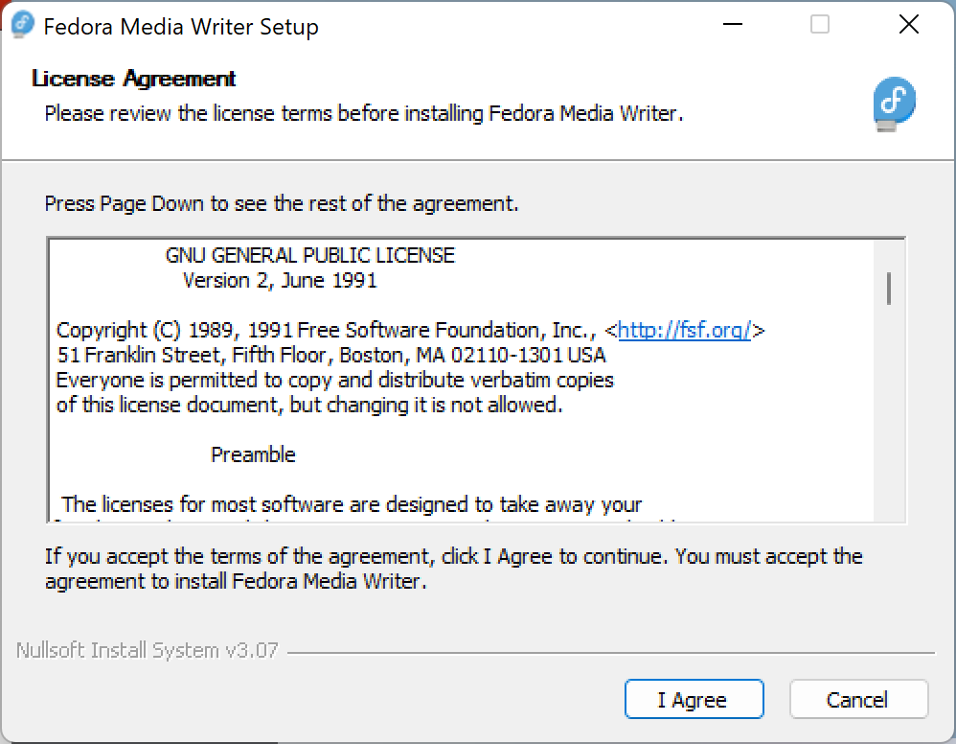
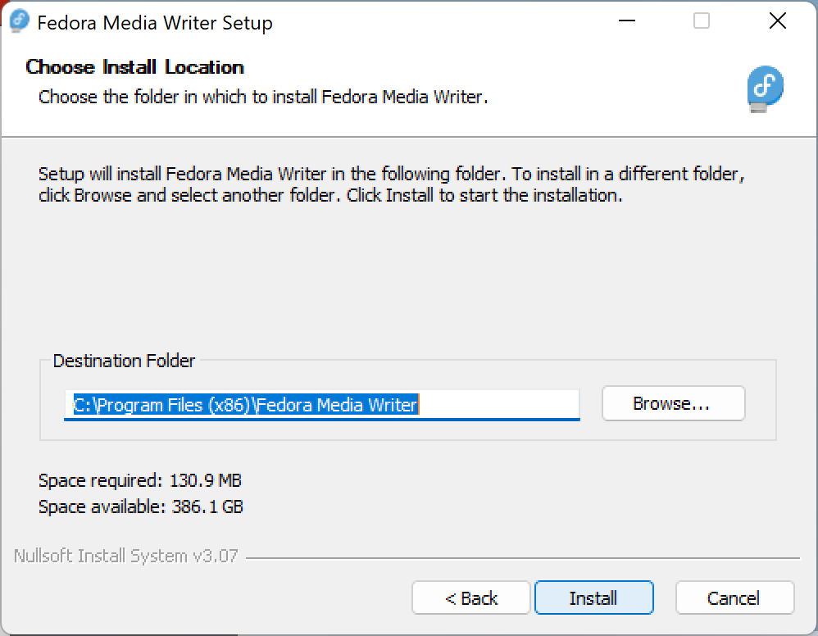
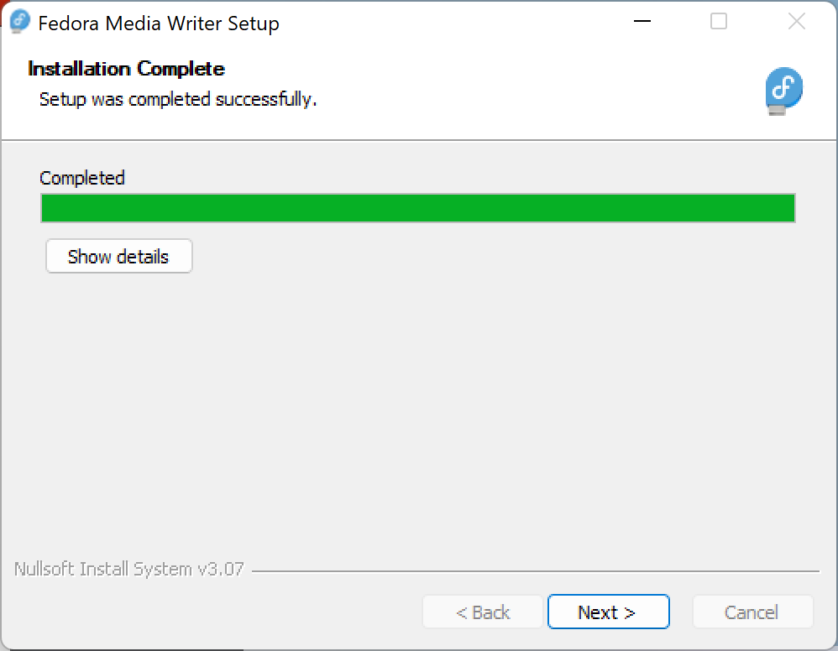
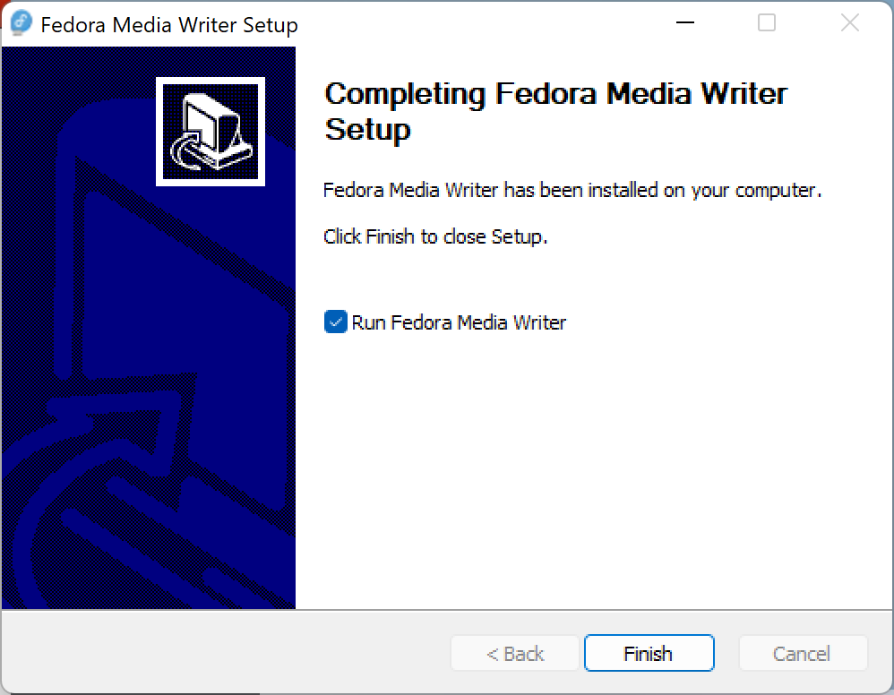
- Click on the “Next” button.
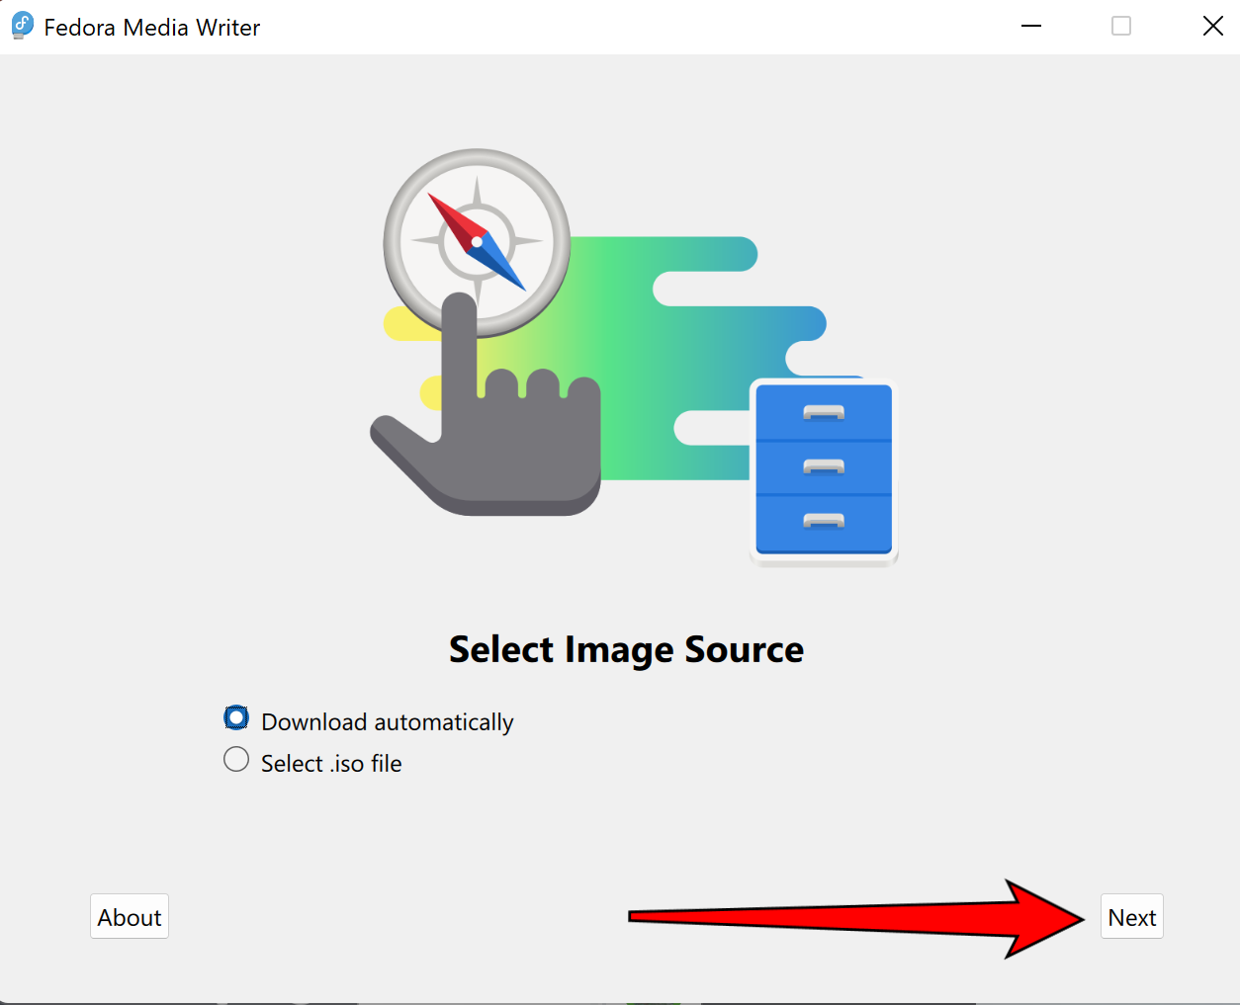
- Click on the “Next” button.
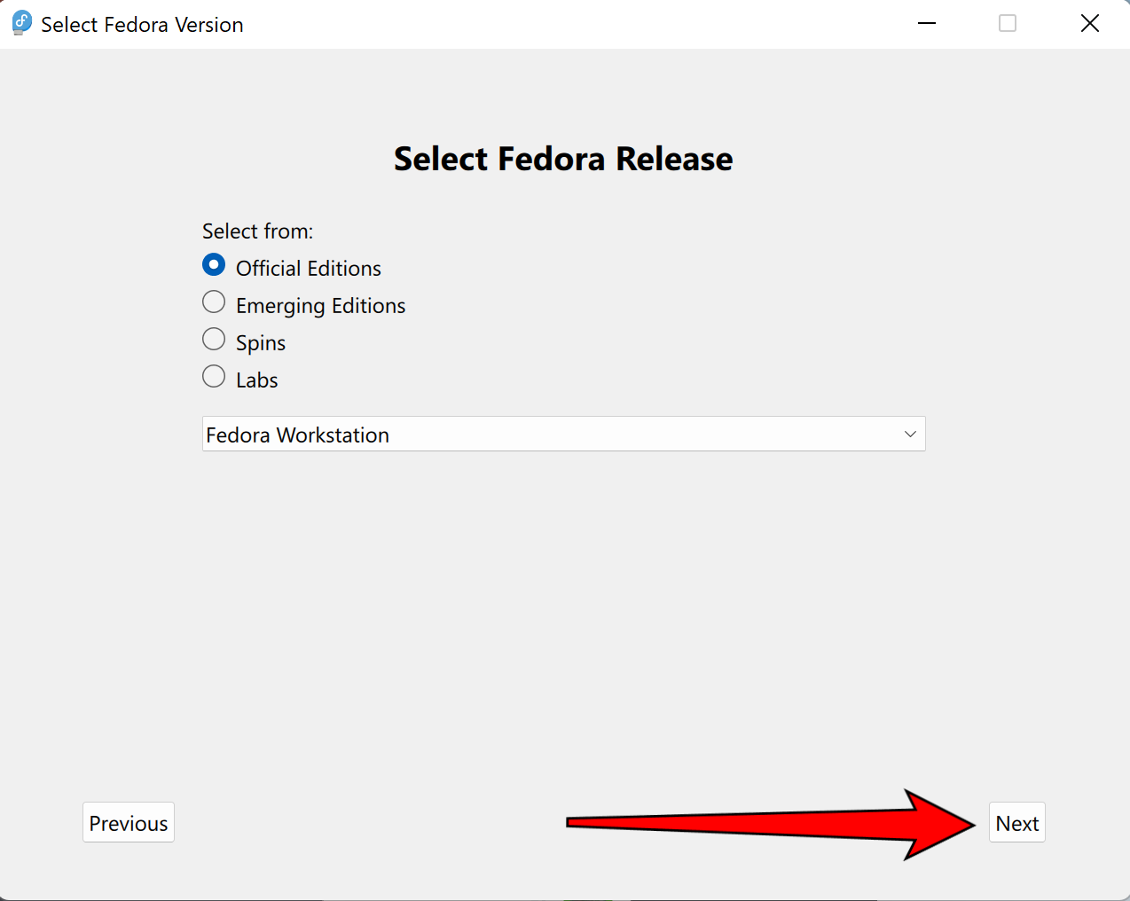
- Select your USB Flash Drive.
- Select the “Delete download” option to save you some disk space.
- Simply press the button “Write” and wait for it to finish.
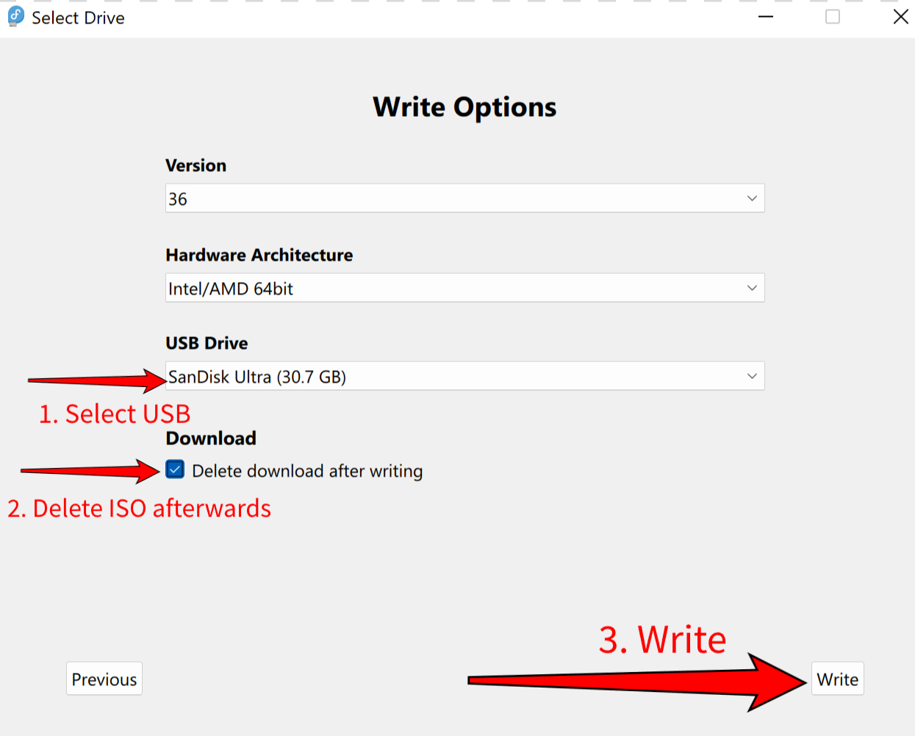
- You should see no error message and click “Finish”. You are good to go!
- (P.S. if there’s any error message, please contact the Linux Support Officer)
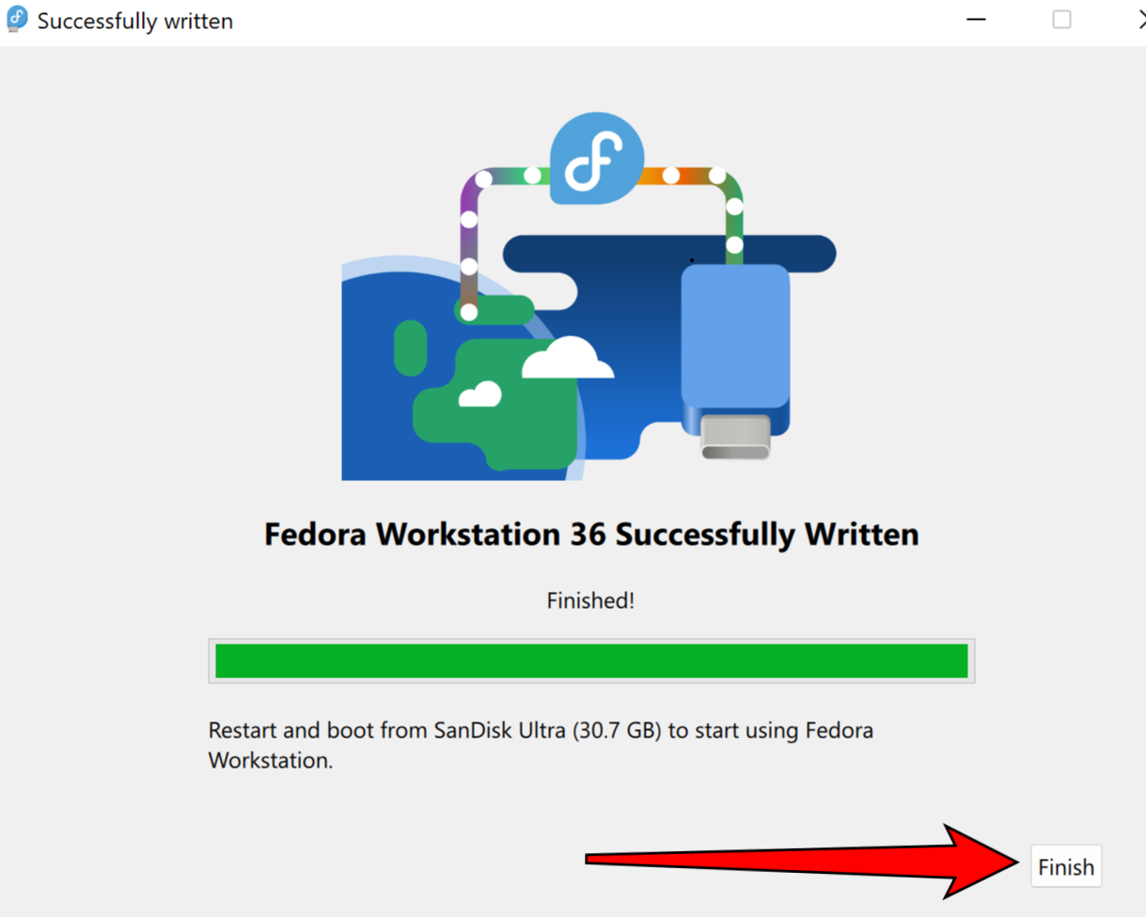
Step 4. Entering the boot session (In short)
- Reboot your PC
- Press Del and wait for a menu to pop up, then select your USB as a boot device.
- If 2. is not working, please follow 4.
- Press F2 to enter the boot session and select your USB as the first boot loading device
If there are any difficulties getting the USB to boot, check out the Youtube link below for getting into the Boot Menu;
Regular Desktop:
https://www.youtube.com/watch?v=wH9q3KSISvQ

Apple Computer:

https://www.youtube.com/watch?v=XJDwF1BY66Y

You shall see the following screen with Two Options
[Try Fedora] and [Install to Hard Drive]:
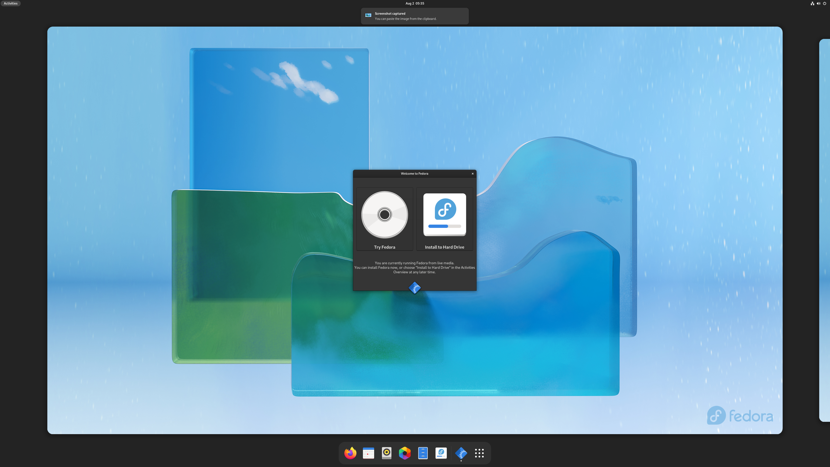

Step 5. On your Fedora screen, move your mouse to the top-left corner of your screen. You should see the following screen:
Example Output:

Step 6. Left Click “Type to search”.
Example Output:
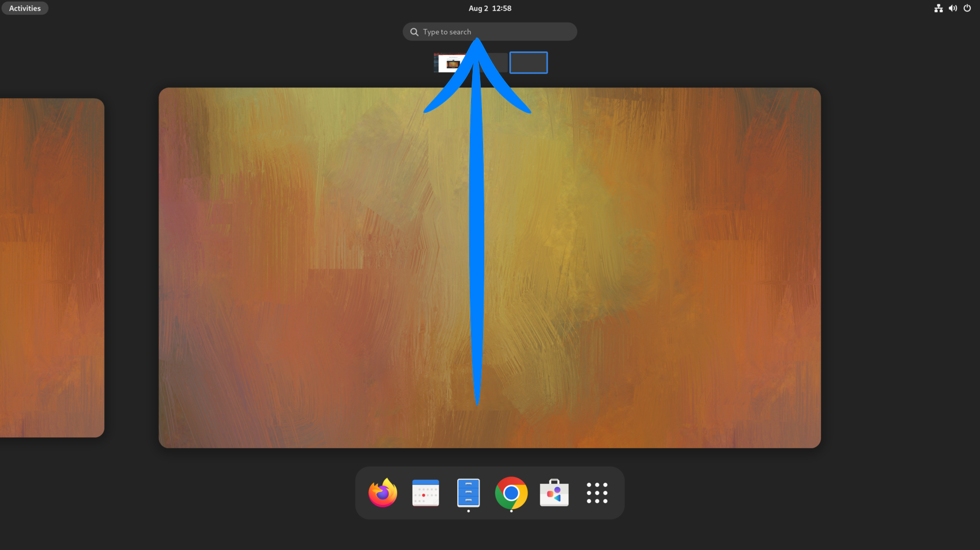
Step 7.Enter the word “disk”.
Example Output:

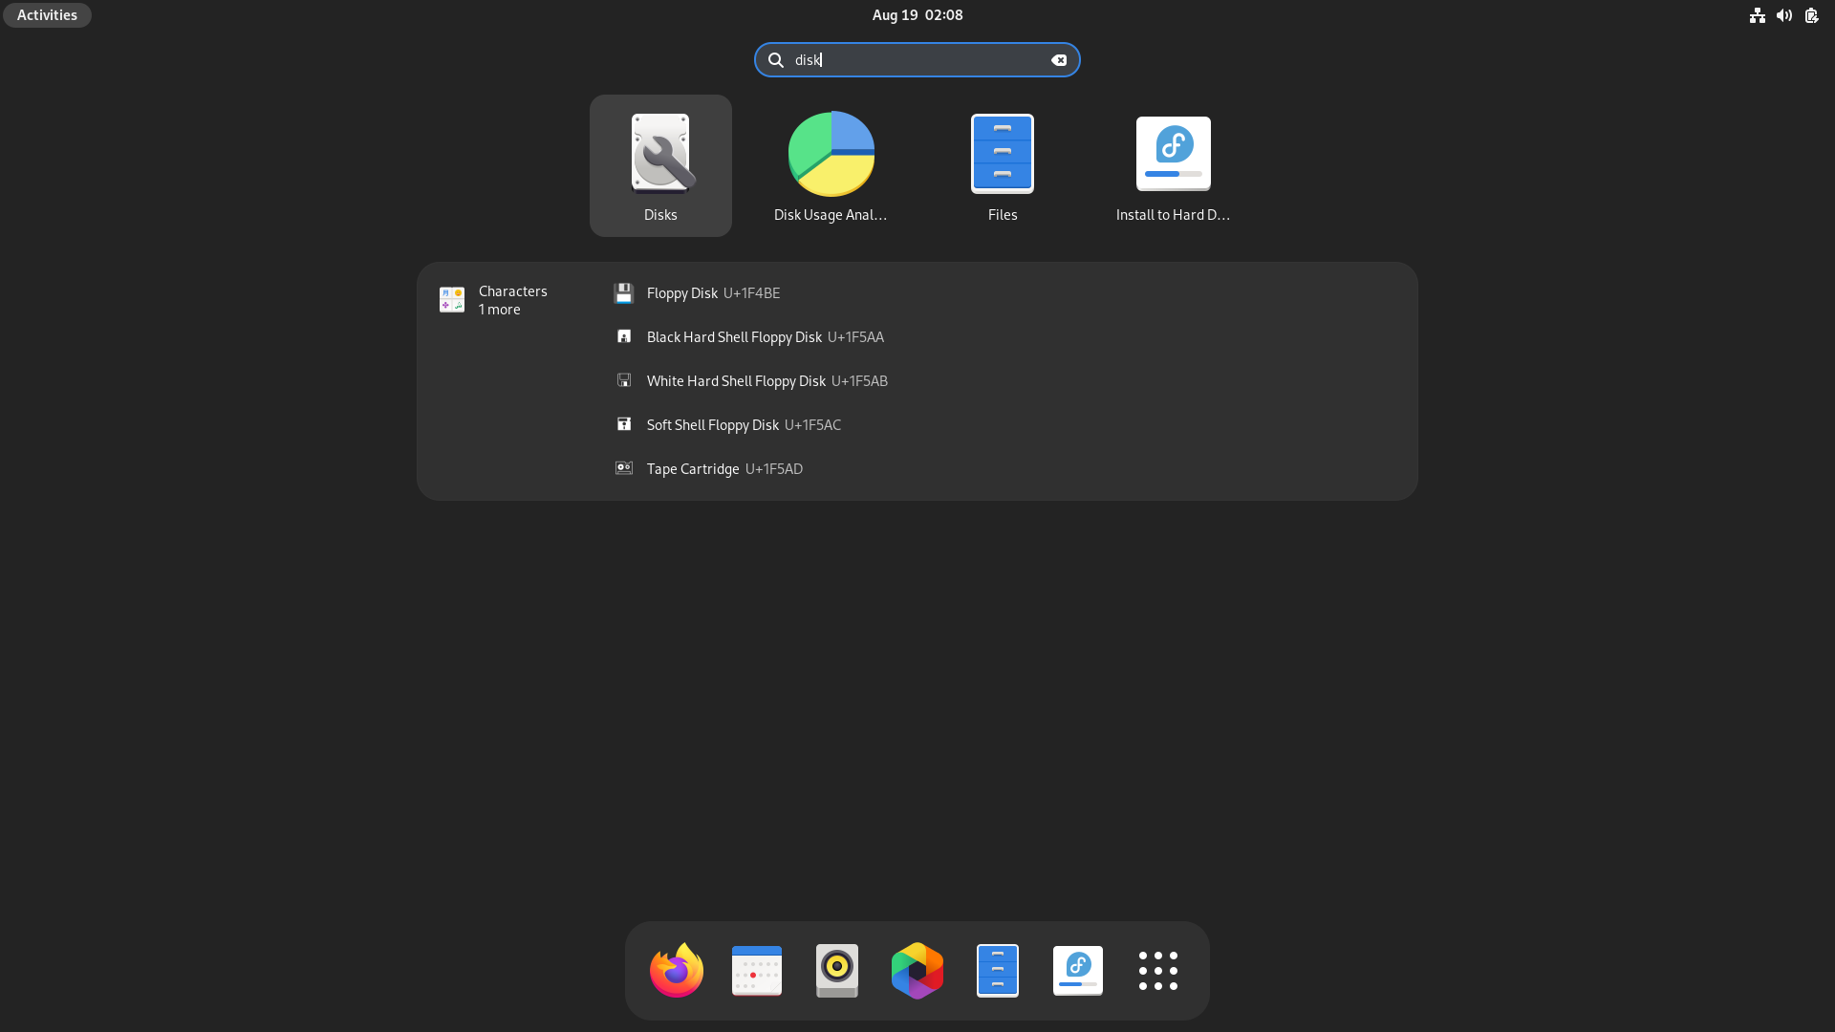
Step 8. After Left Clicking on the disk Icon. You should see the following window pop out. Go ahead and select the disk to install Fedora.
(This is a Formatting Operation, All data in the disk will be erased)
Example Output:
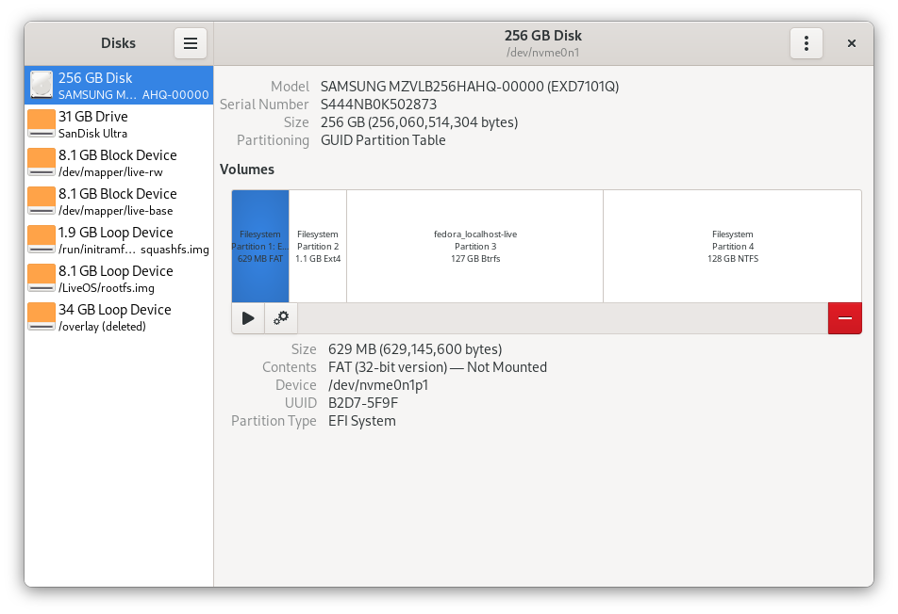
Step 9. Follow the arrow and Click on Format Disk. Then Format Disk window will pop out.
Example Output:
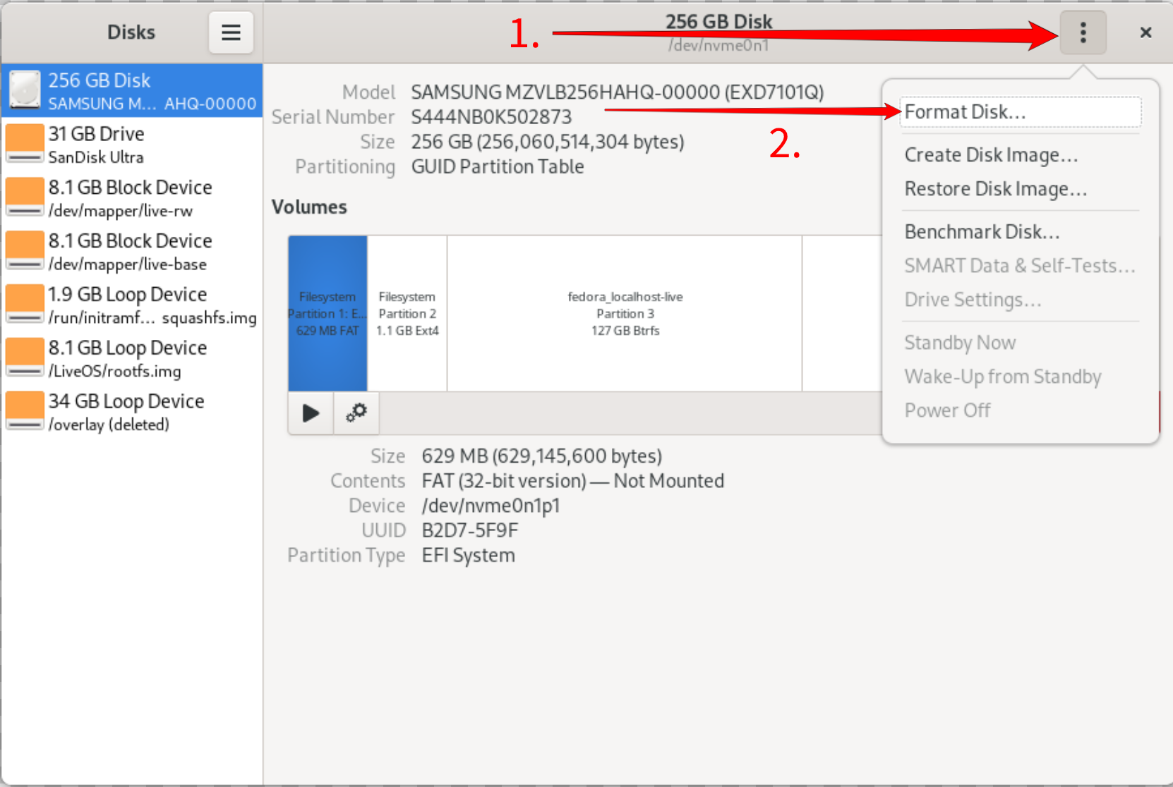
Step 10. Left Click on the Format Button.
Example Output:
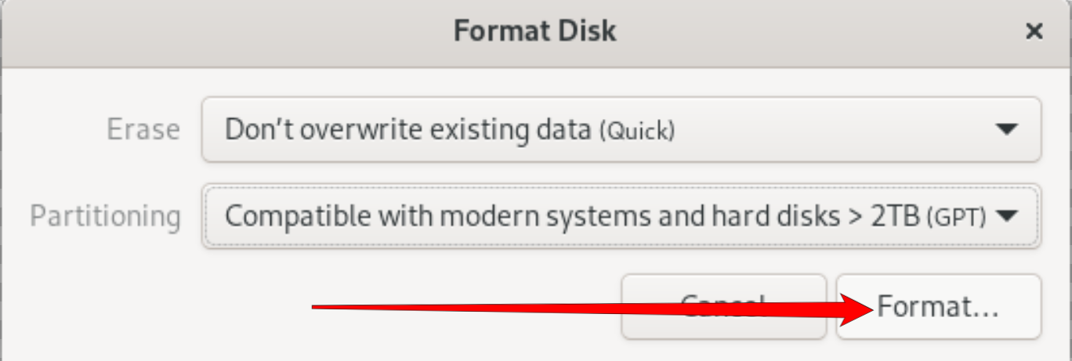
Step 11. a warning will show up, Click on the Format Button to confirm.
(Again, All data in the disk will be deleted from the disk)
Example Output:
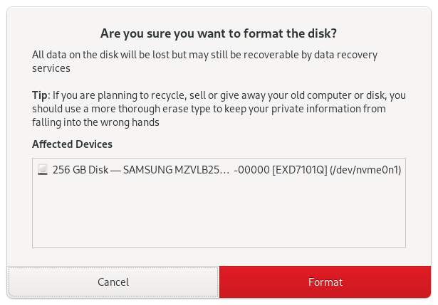
Step 12. Fedora will then ask for Permission, Click on the Authenticate Button to confirm.
(Again, All data in the disk will be deleted from the disk)
Example Output:
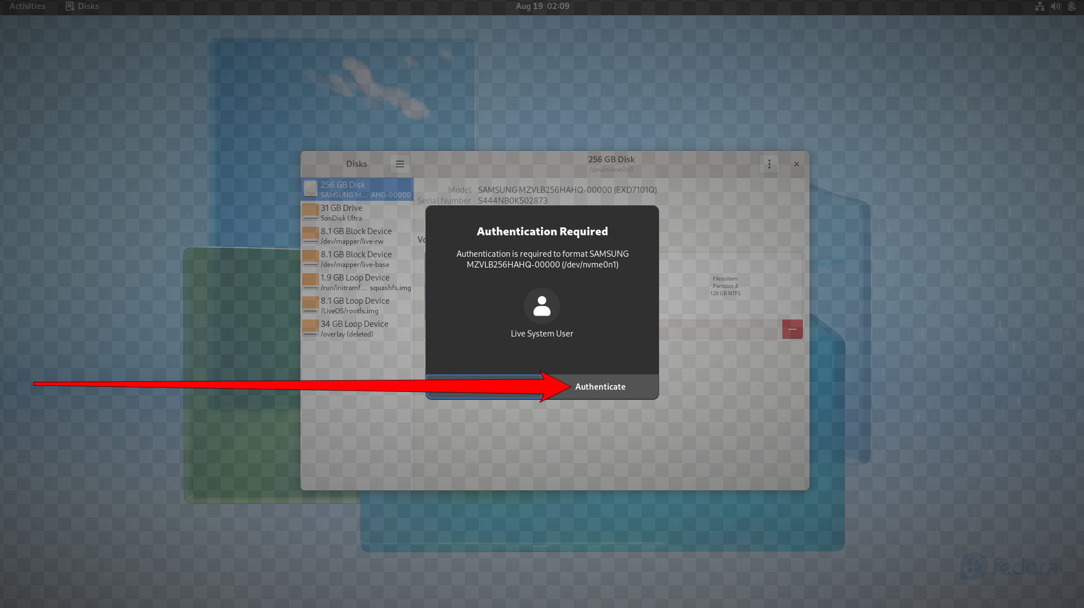
Step 13. Fedora Within the Disk Window, you should see they are now Free Space.
Example Output:
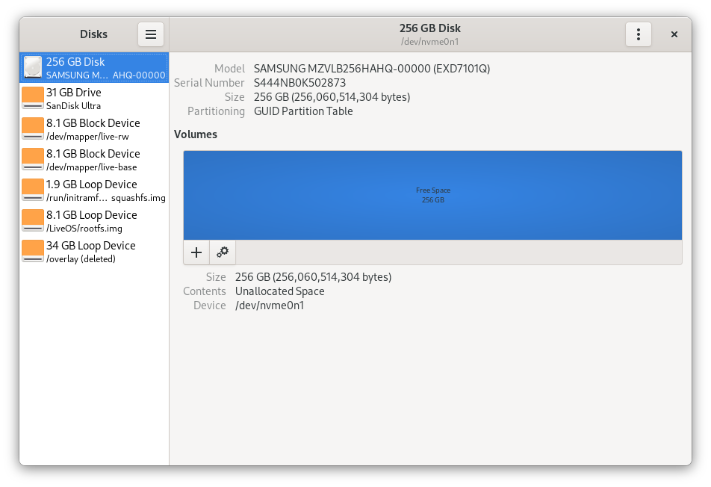
Step 14. Follow the Step 5-7, but instead of searching “disk”, search “install to hard drive”.
Example Output:
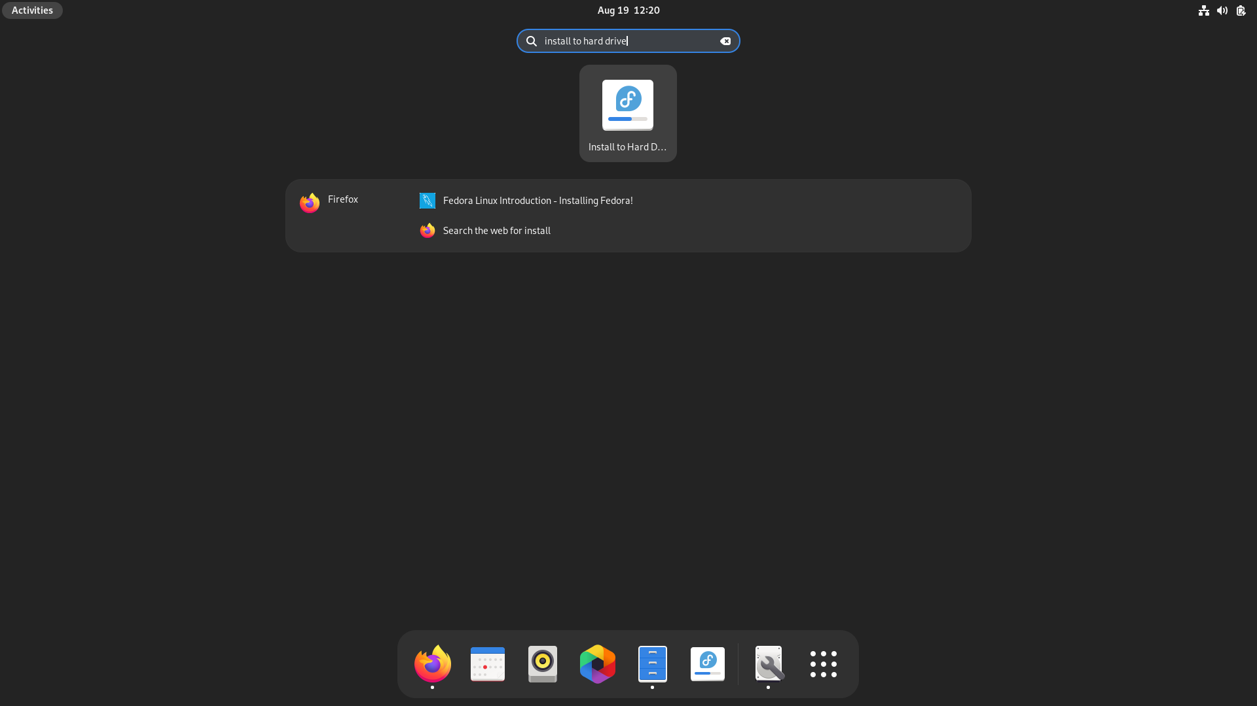

Step 15. Select the icon [Install to Hard Drive] and it will lead you to this screen:
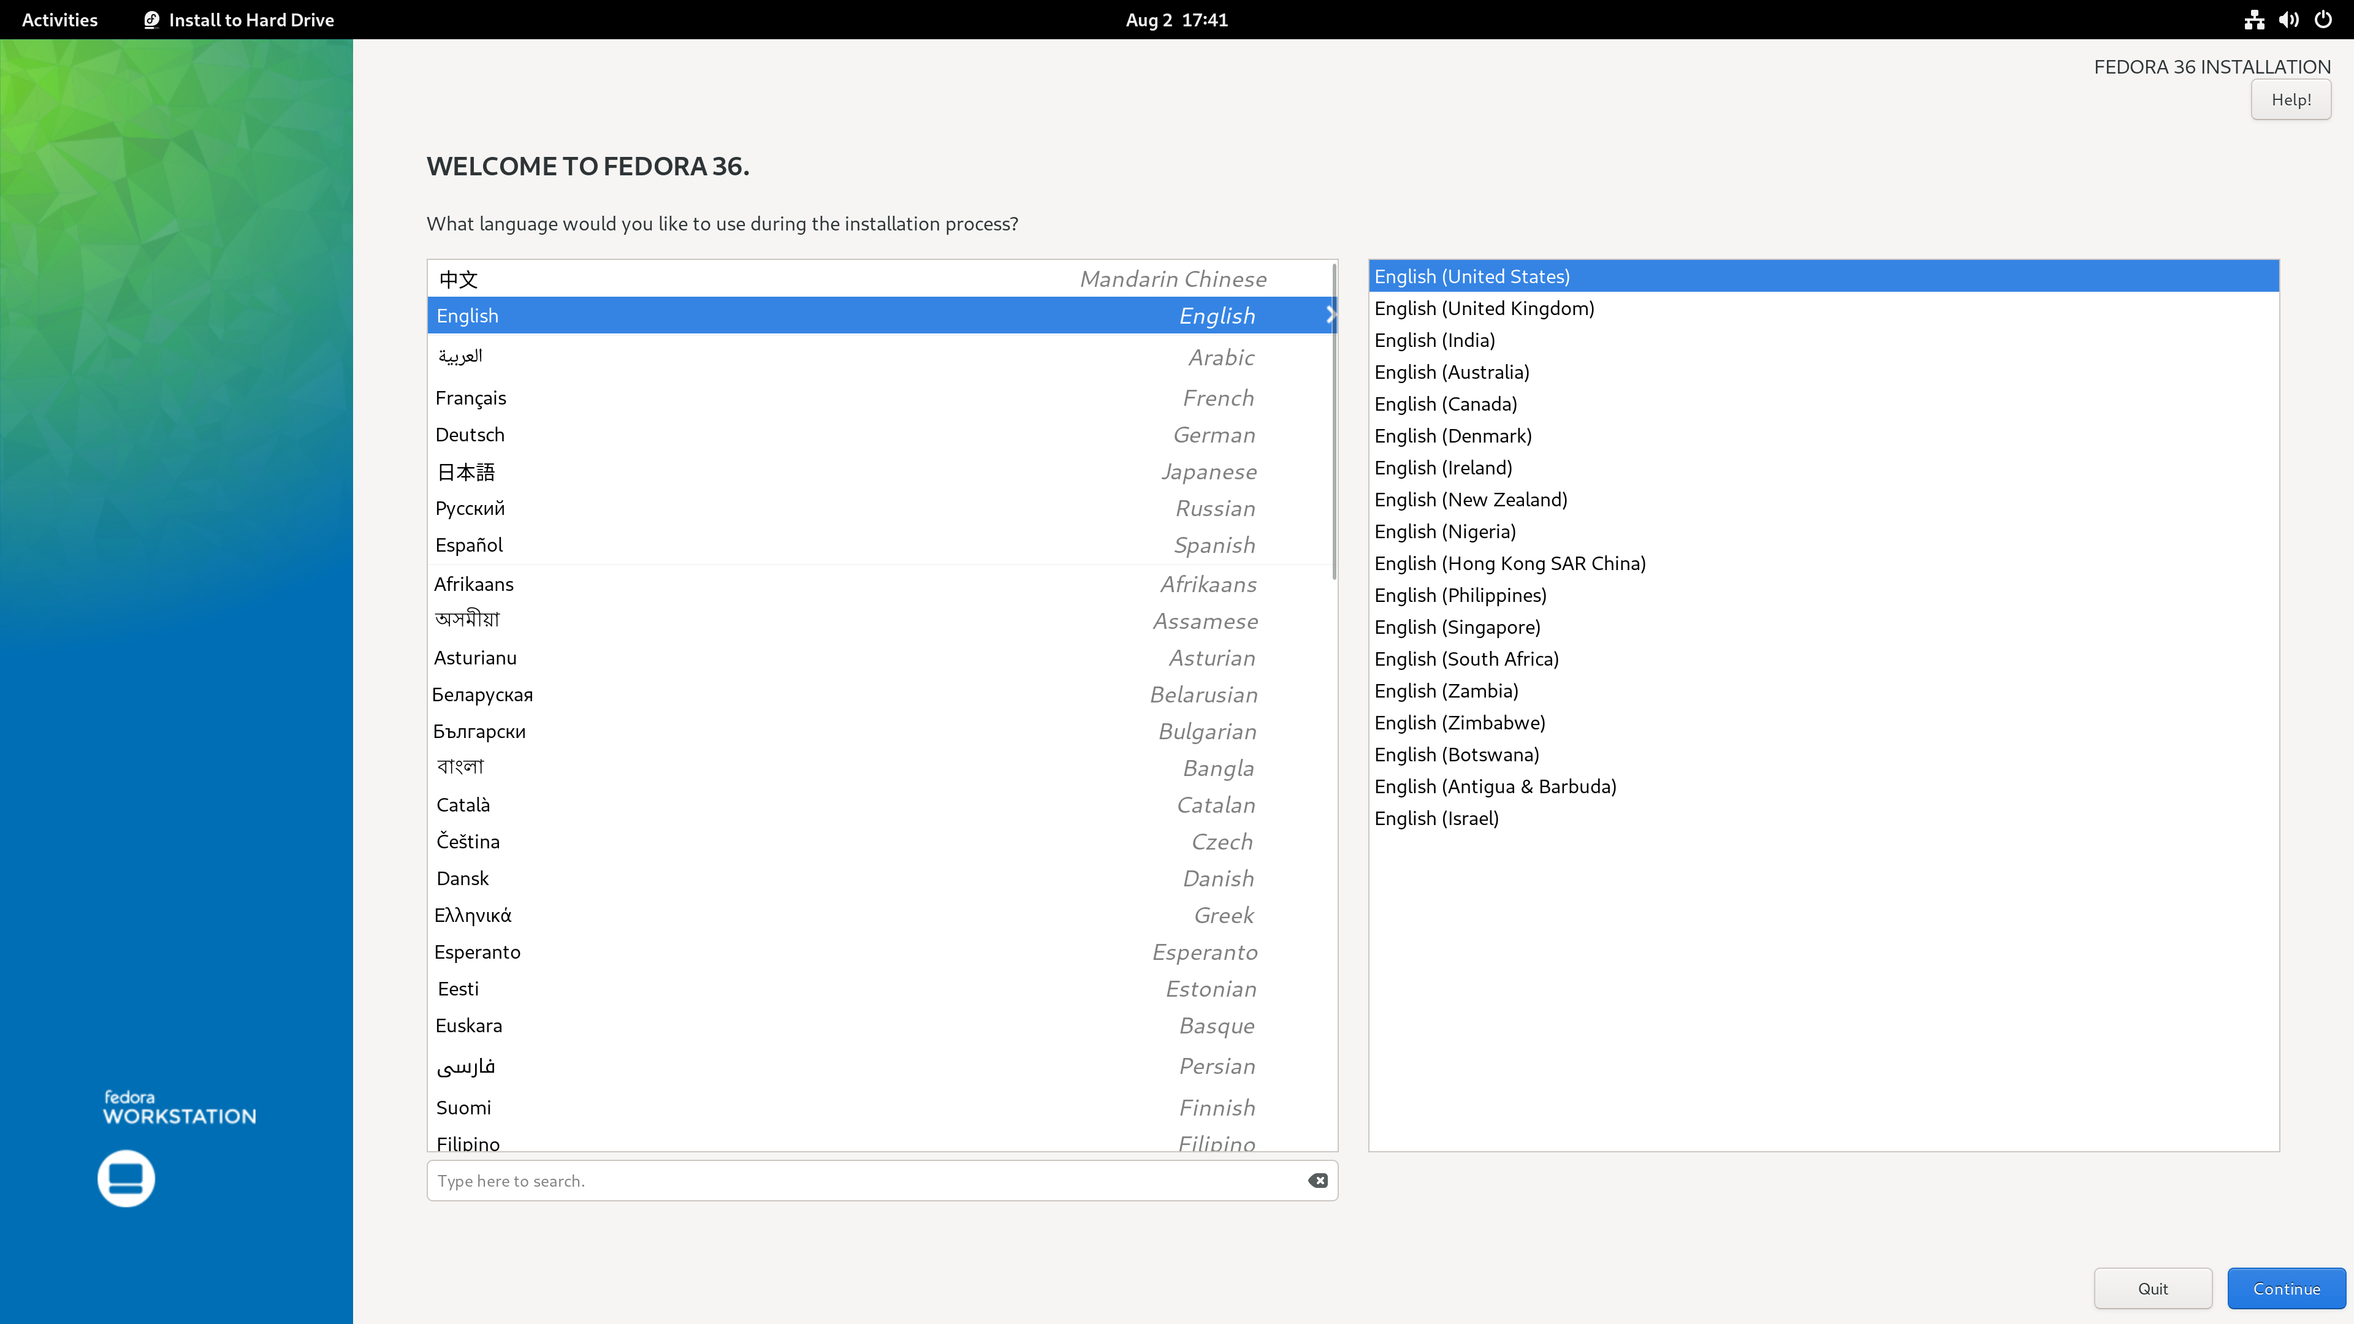
Step 16. Select your preferred language and press the blue button in the bottom-right corner.
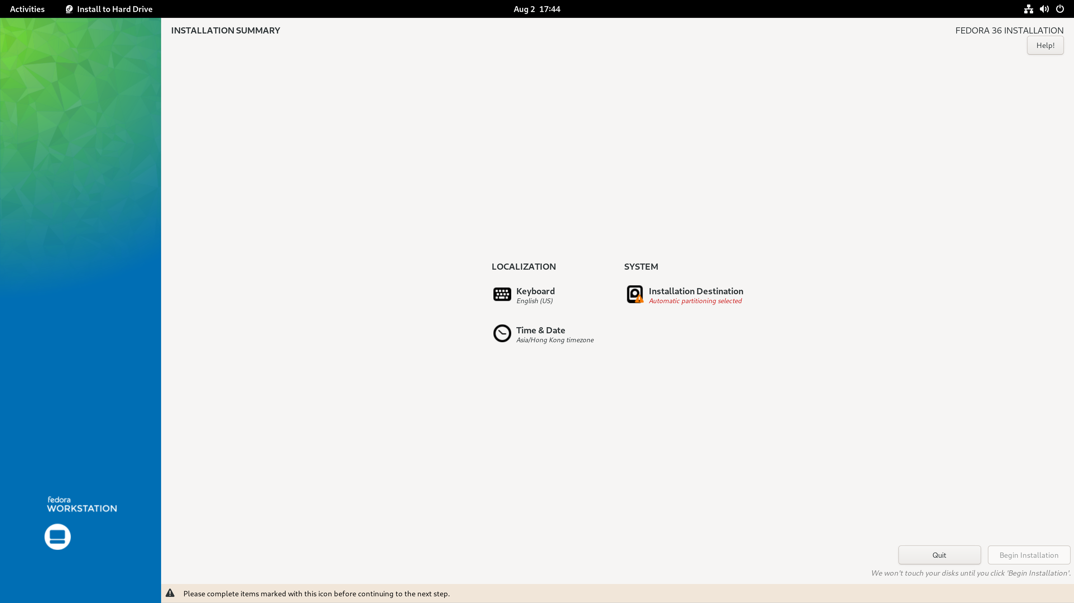
Step 17. An “Installation Destination” label is located in the centre of the screen. Left Click on it.

Step 18. Now select the Disk Location that you would like to install on. In my case, there’s only one Disk I could select.
P.S. if you plan on installing Fedora onto another drive, go ahead selecting it.
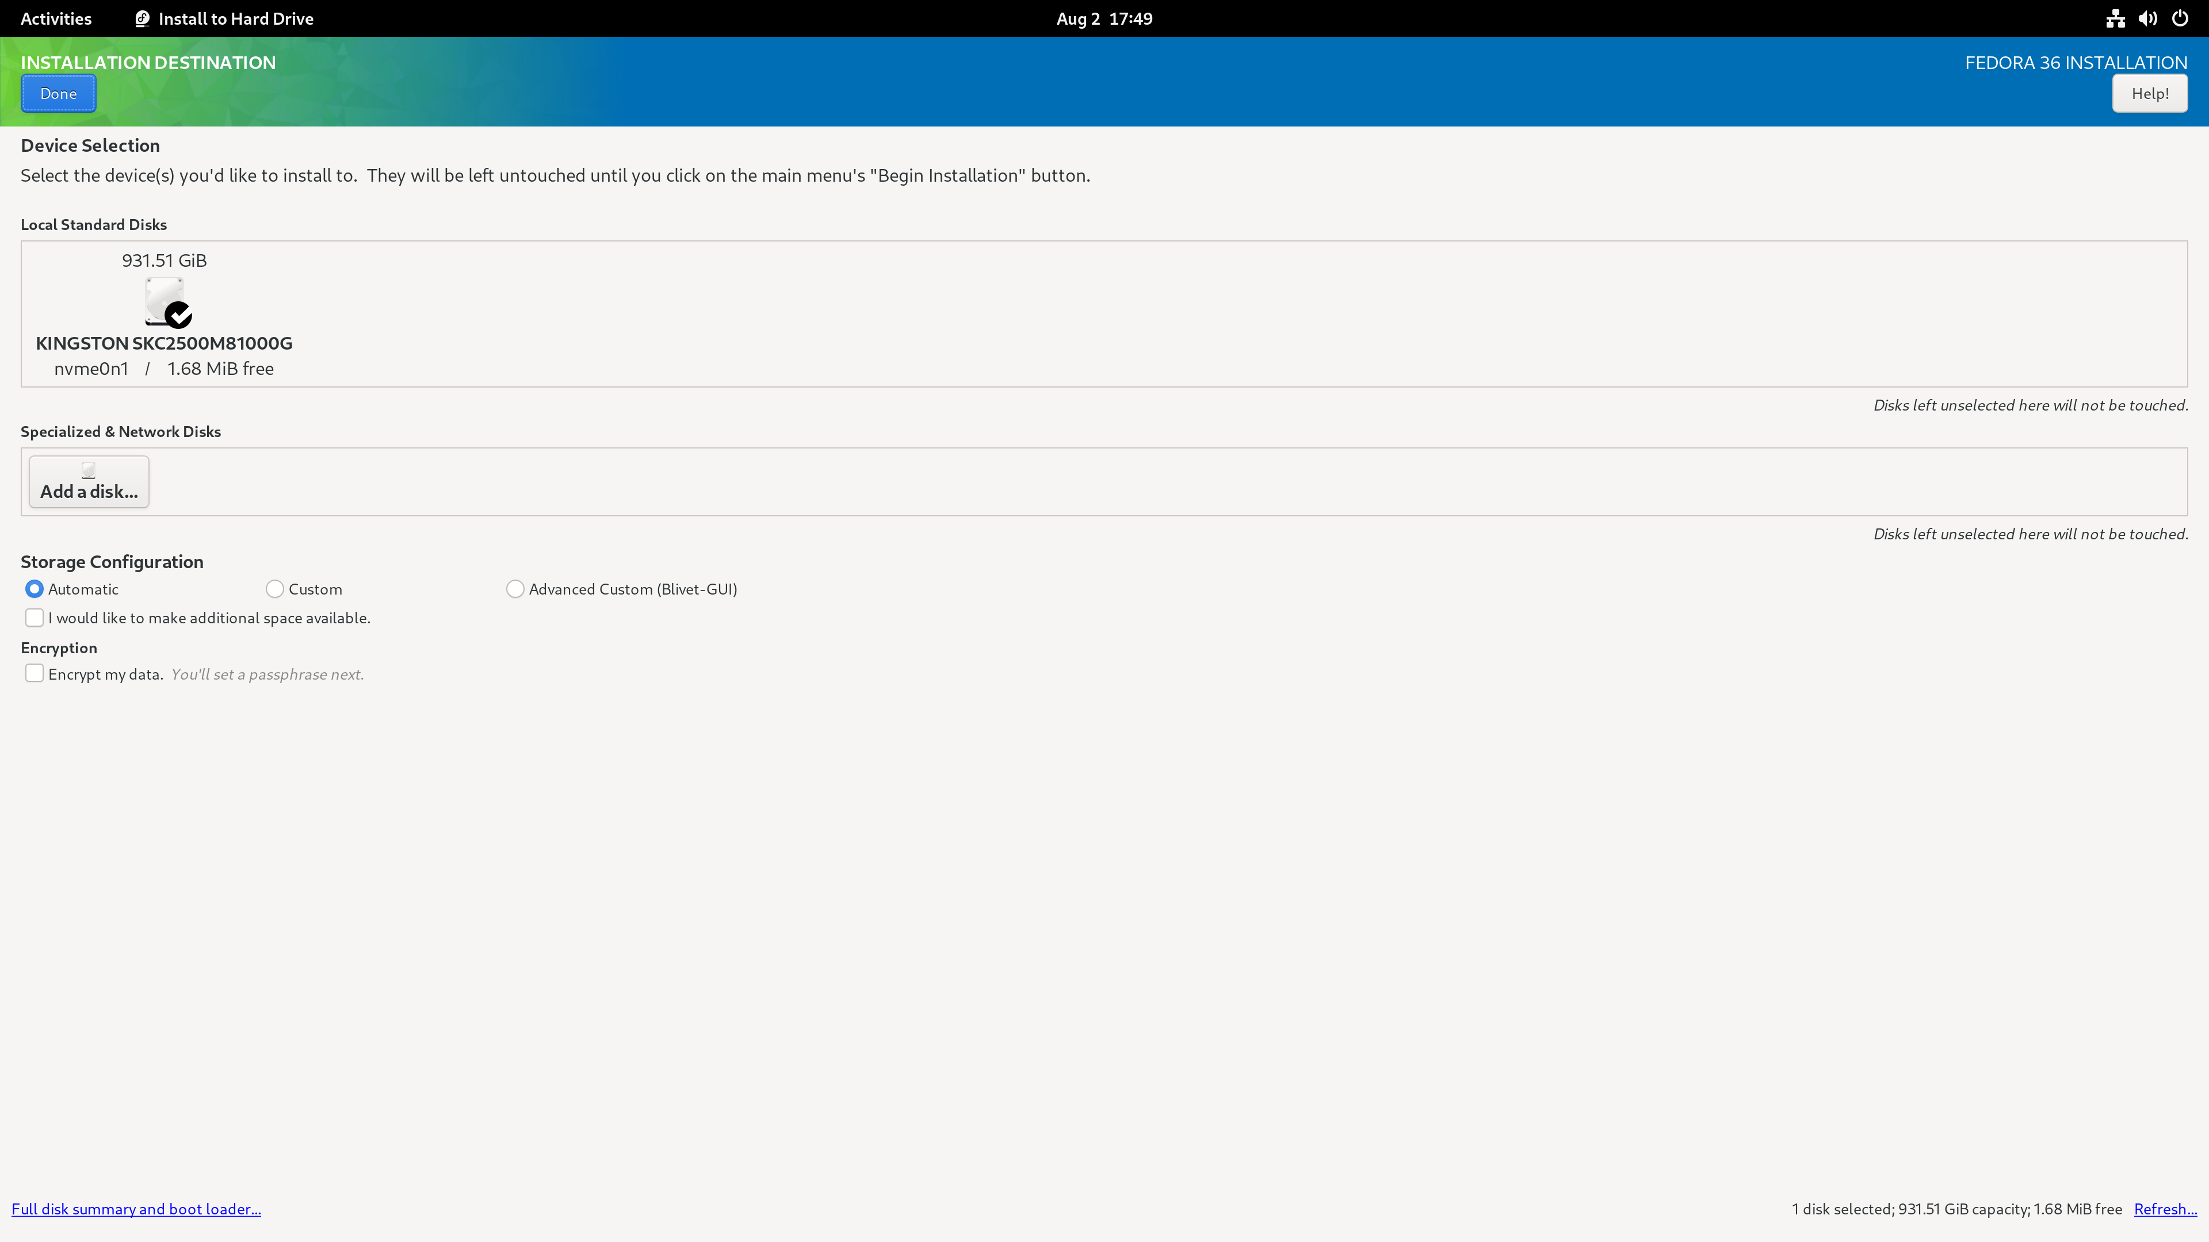
Step 19. Now select the Disk Location that you would like to install on. In my case, there’s only one Disk I could choose. Than, Left Click the Blue Button “Done” in the top-left corner.
P.S. if you plan on installing Fedora onto another drive, go ahead selecting it.

Step 20. Finally, Left Click on the “Begin installation” Blue Button in the bottom-right corner and wait for several minutes.
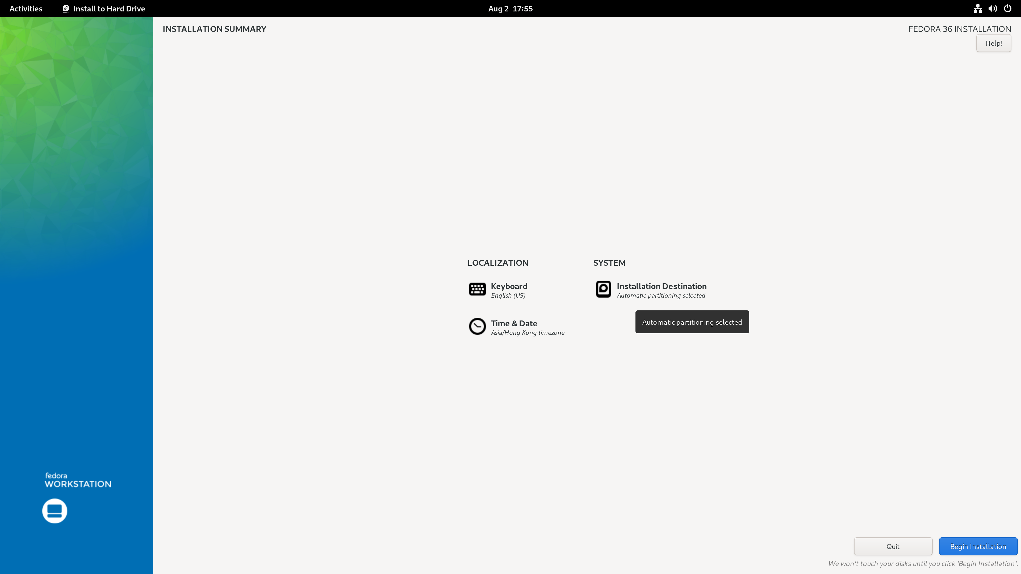
Step 21. Reboot your PC and enjoy Fedora!

E.N.D

Installing Rpm Fusion (DNF)
The RPM Fusion project is a community-maintained software repository providing additional packages that are not distributed by Fedora.

Remarks: If you need further assistance on advanced installation, please refer to this link.

1. Enabling the RPM Fusion repositories using command-line utilities

Step 1. First, on your Fedora, move your mouse to the top-left corner of your screen.
You should see the following screen:

Example Output:

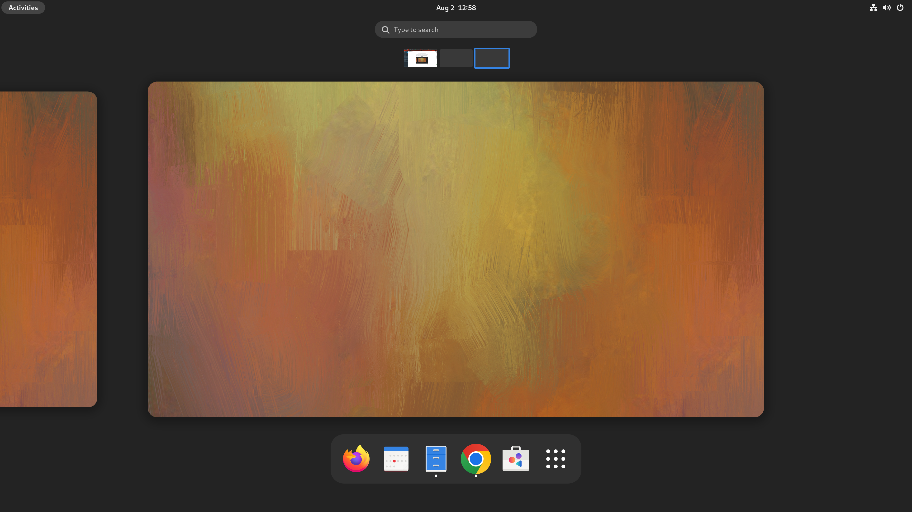

Step 2. Left Click “Type to search”.

Example Output:
Step 3. Enter the word “Terminal”.

Example Output:
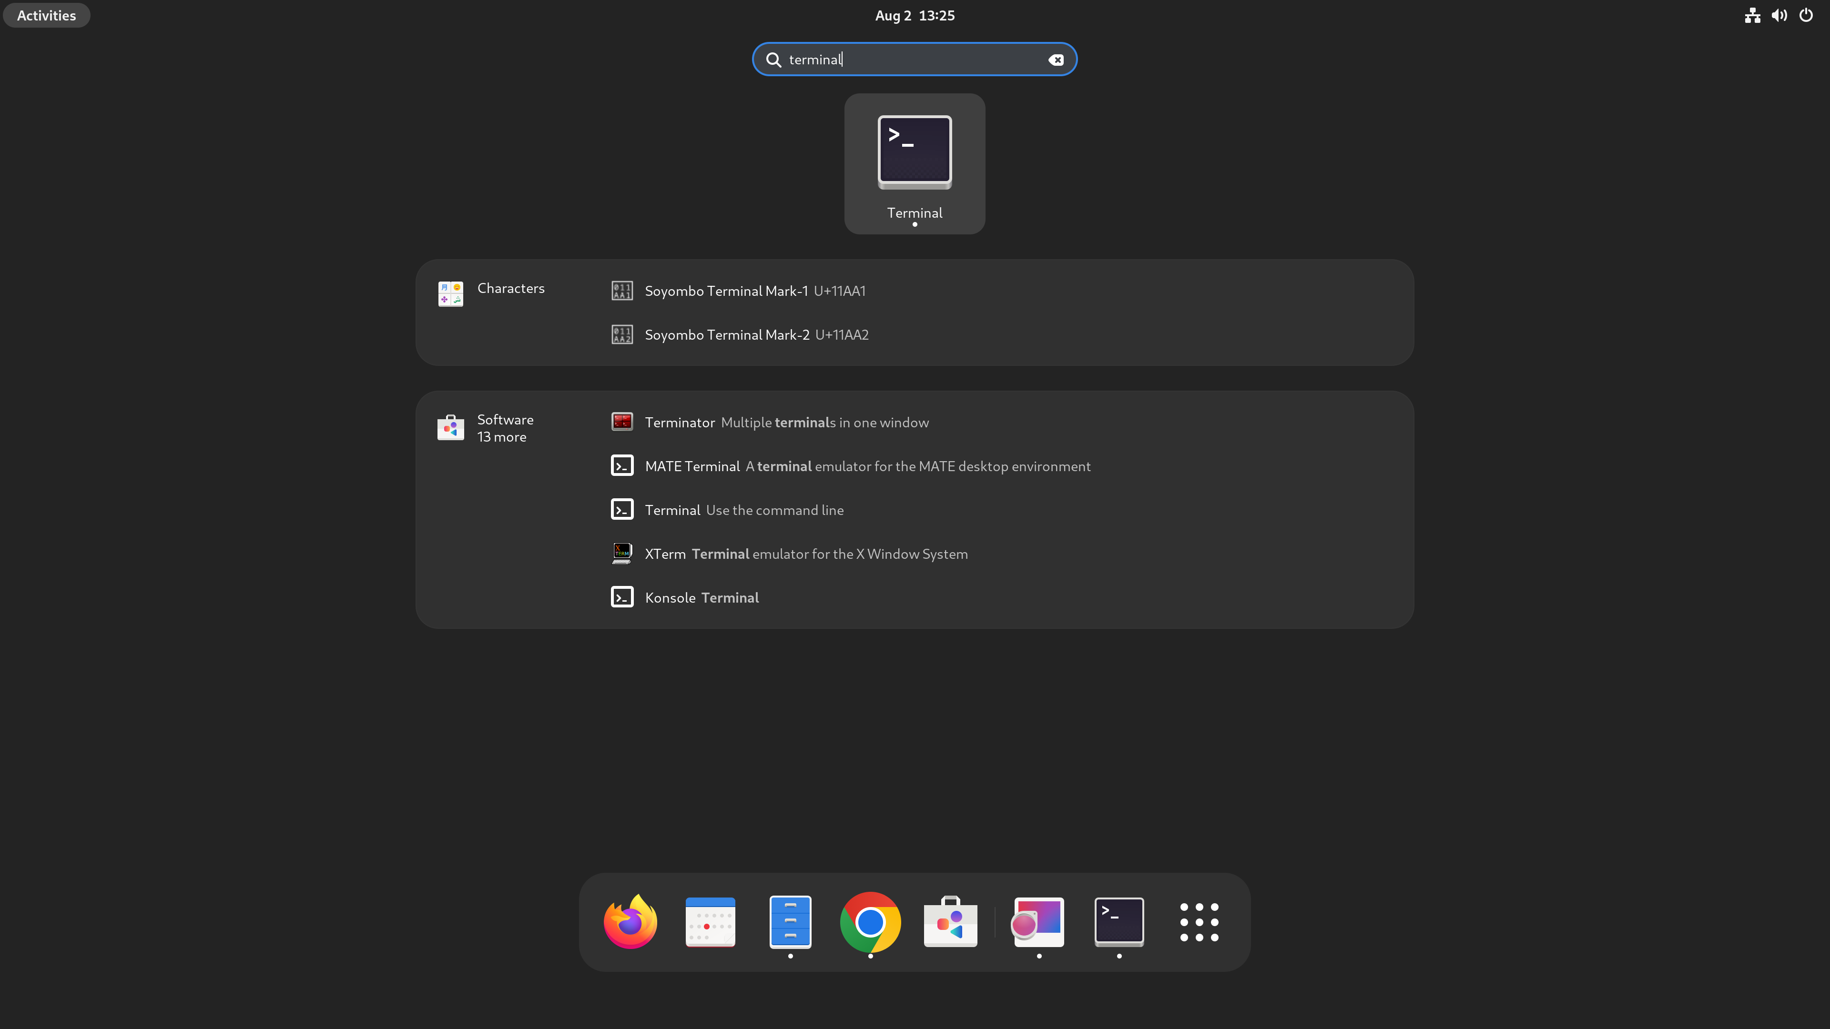

Step 4. After Left Clicking on the Terminal Icon. You should see the following terminal pop out.

Example Output:
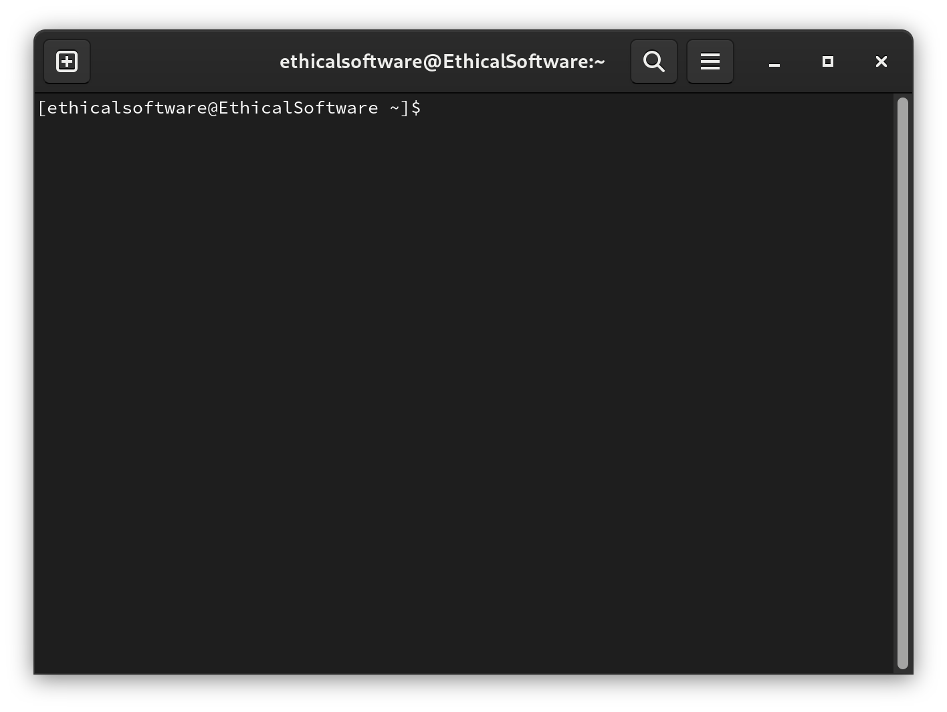
Step 5. Enter the below command in the terminal and enter your user password:

sudo dnf install https://download1.rpmfusion.org/free/fedora/rpmfusion-free-release-$(rpm -E %fedora).noarch.rpm

Example Output:
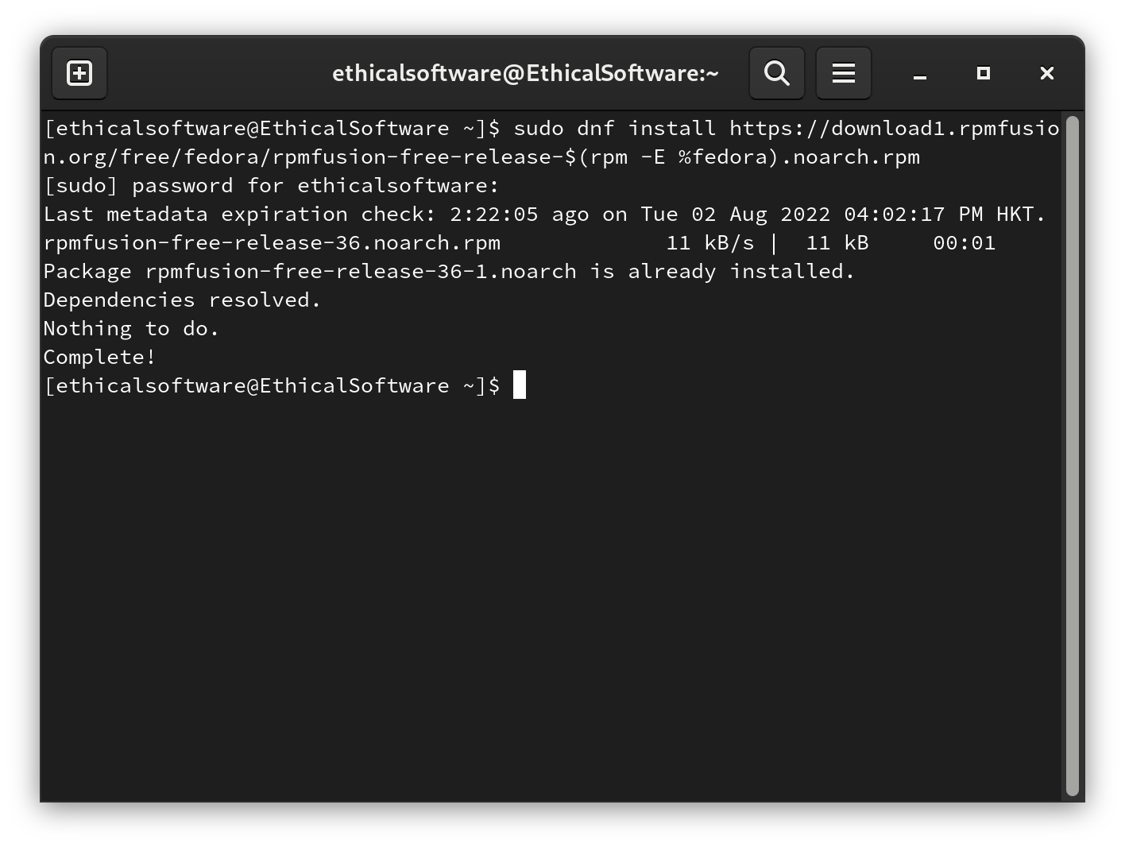
Congregation! You have successfully installed Rpm Fusion on Fedora!

E.N.D

Installing Rpm Dependency/Packages (Yum)

RPM Package Manager is a free and open-source package management system. User’s can install Rpm Dependency or Packages with RPM Package Manager.

Rpm command only worked decently with individual packages with a small number of Dependencies. On the other hand, Yum worked fine even with a complex list of Dependencies. In this case, we will prefer installing Rpm Packages via Yum.

Step 1. First, on your Fedora, move your mouse to the top-left corner of your screen.
You should see the following screen:

Example Output:

Step 2. Left Click “Type to search”.

Example Output:
Step 3. Enter the word “Terminal”.

Example Output:

Step 4. After Left Clicking on the Terminal Icon. You should see the following terminal pop out.

Example Output:
Step 5. Enter the below command for checking the Rpm dependencies of <package-name>
(Taking Apache HTTP Server as an example):
rpm -qR httpd
Example Output:
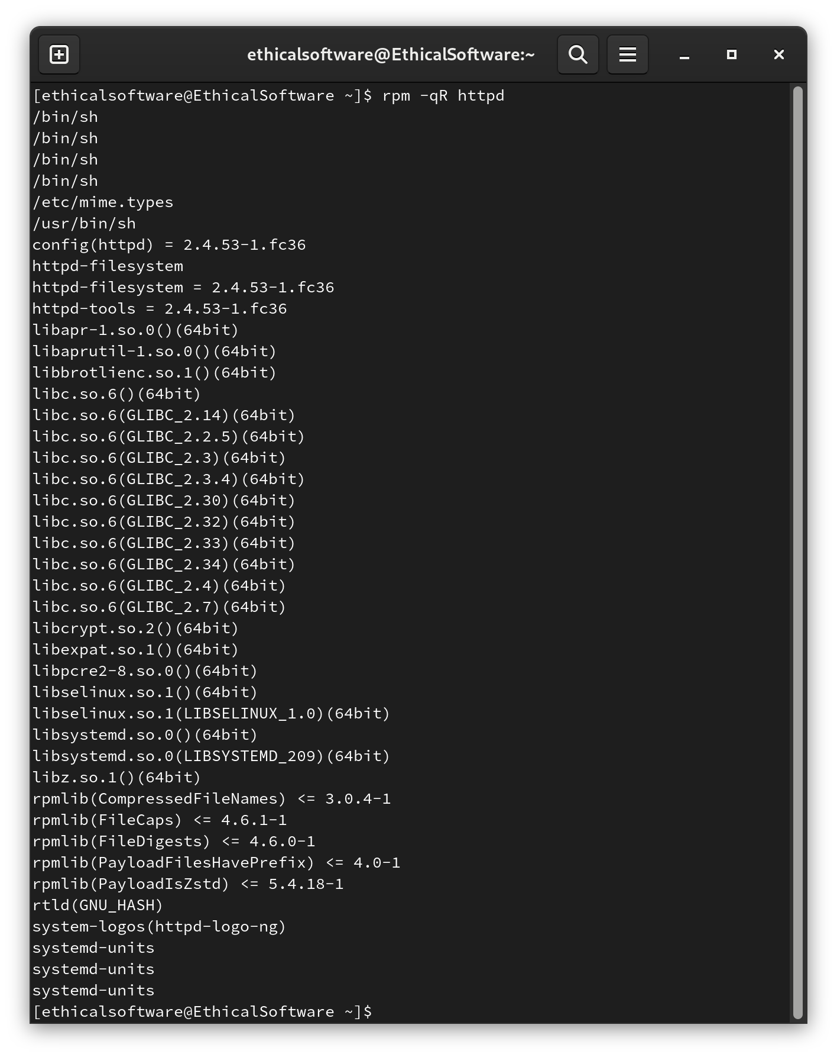
Step 6. Enter the below command for installing the specified <package-name>
(Taking Apache HTTP Server as an example):
Enter the “y” key. You are good to go if you don’t see any Error messages.
sudo yum install httpd
Example Output:
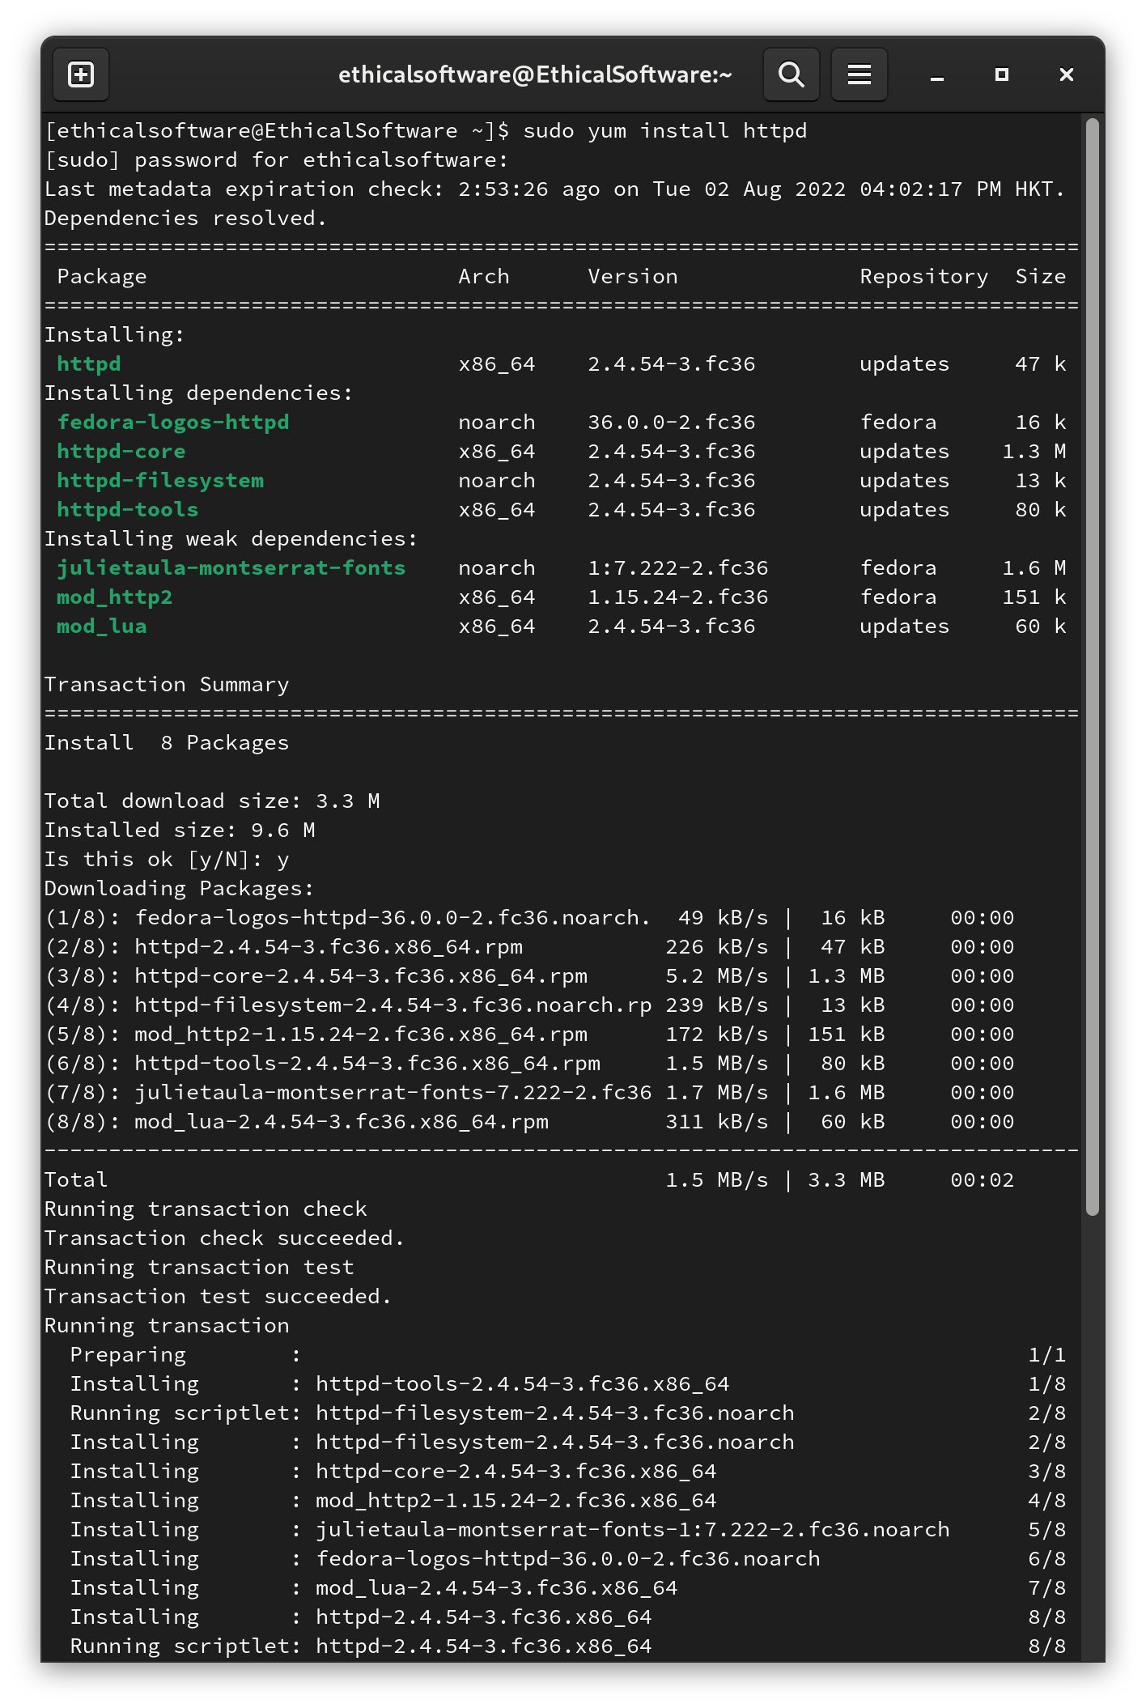
E.N.D

Easiest apps Installation from “Software” (App store)
It is better to start things graphical as some beginners might get lost/confused when dealing with Terminal. Here comes Fedora Software”. It is similar to an app store on your smartphone. Simply search apps with a name, and boom! Magic happened.

Step 1. First, on your Fedora, move your mouse to the top-left corner of your screen.
You should see the following screen:

Example Output:
Step 2. Follow the Blue Arrow and Left Click on the “Software” app store Icon :

Example Output:
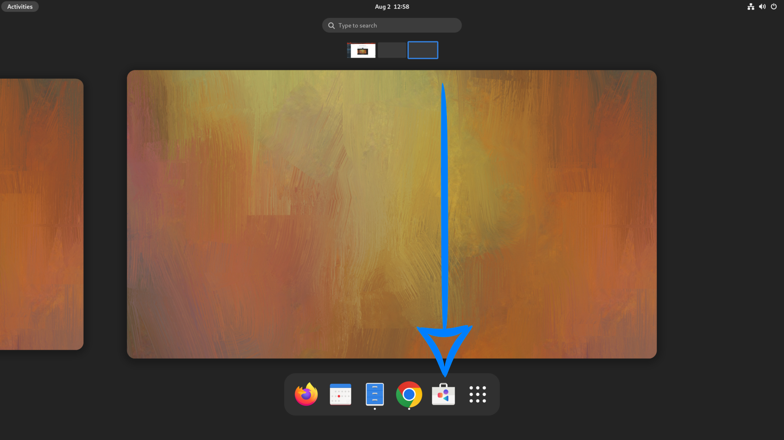
Step 3. You should see the following “Software” store screen, you can find software packages in the suggested categories.

Example Output:
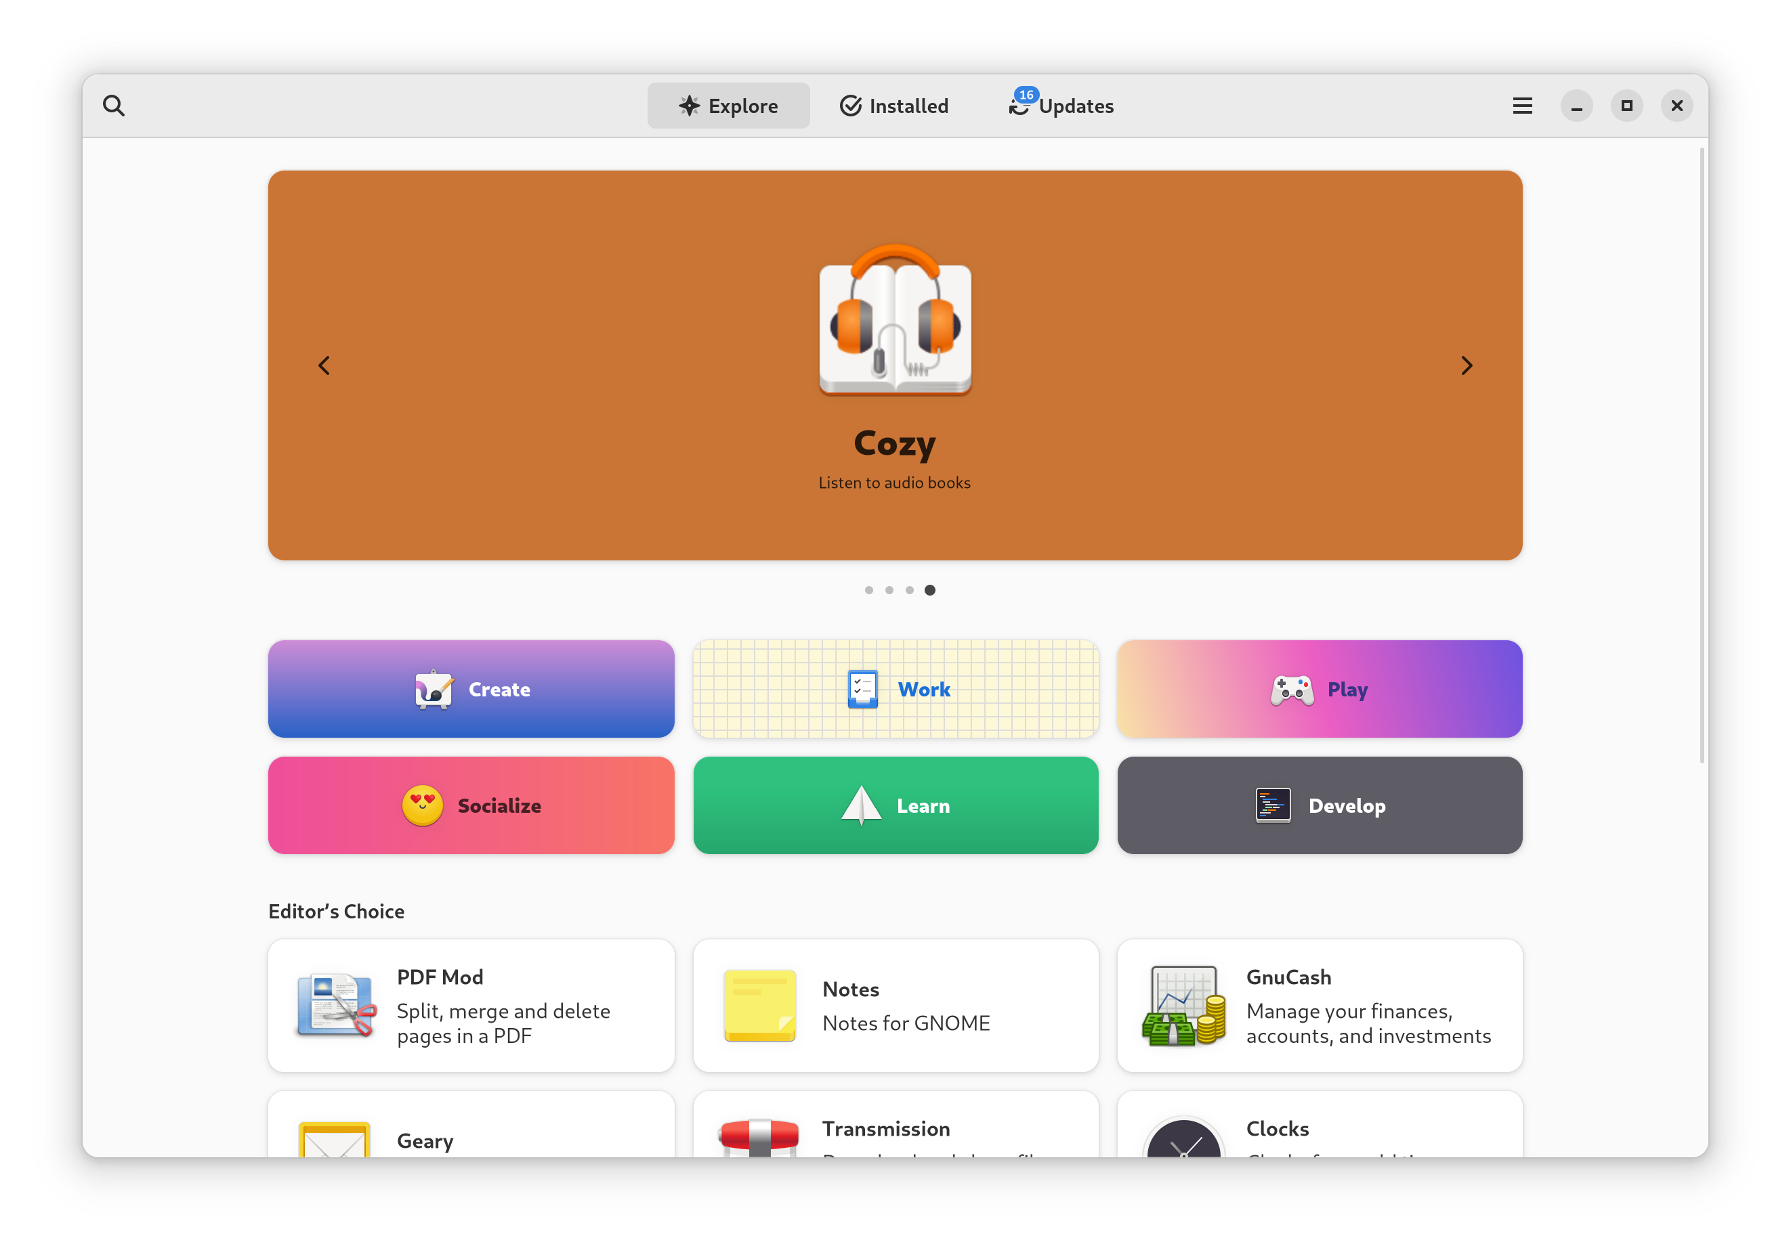
Step 4. On the other hand, if we need to install a specific application. E.g. (music midi apps), we could simply Left Click the search button on the top-left corner of the “Software” store. Afterwards, we can type in “music midi” in the search bar.

Example Output:
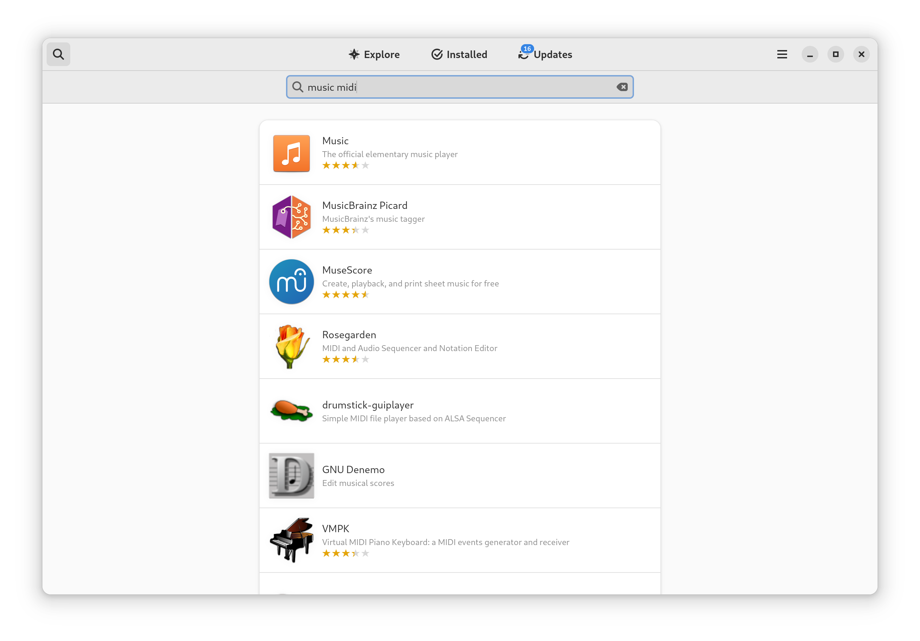
Step 5. As stated in Step 2. we could find valuable tools in the categories. If we go back to the screen in Step 2, we could click on the “Create” Label In the middle of the screen, “Software” would provide us with a series of helpful software when we are creating. E.g. Ardour.

Example Output:
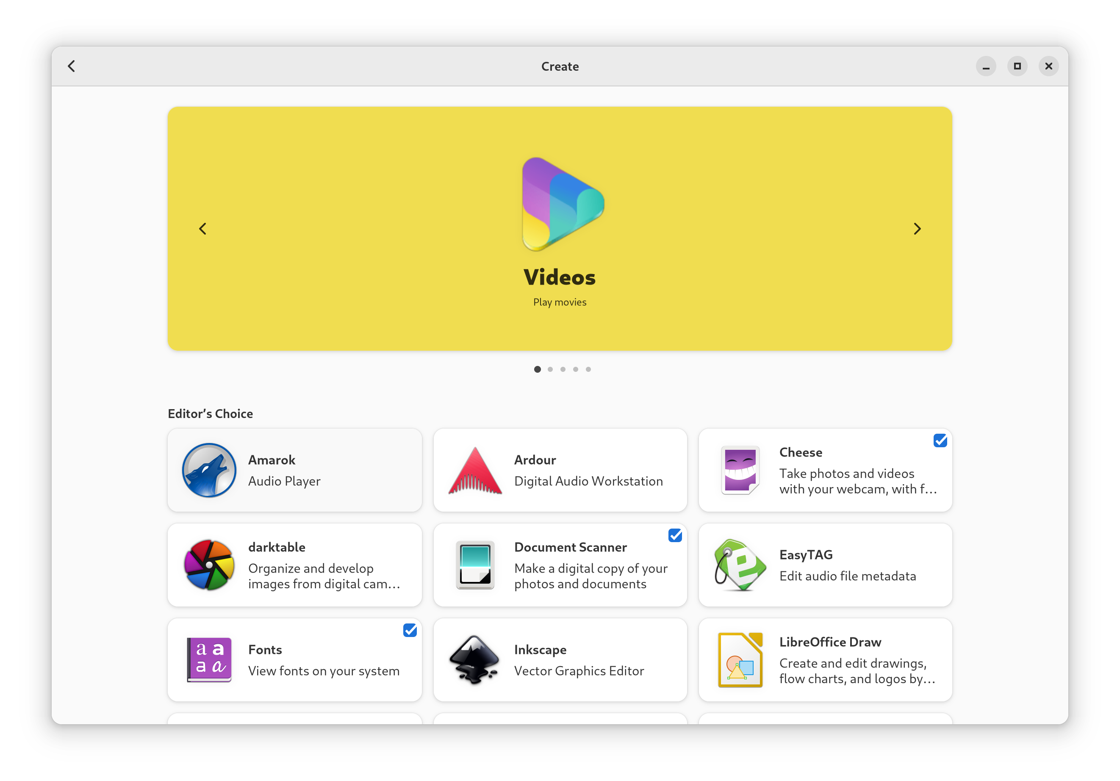
E.N.D

How to Search and Install through DNF (Terminal)
As we have just installed apps in the “Software” store, we could also install them using DNF in a Terminal. DNF is a software package manager that installs, updates, and removes packages on Fedora and is the successor to YUM.
- DNF search and install (To search and install the repositories for a package type)
Step 1. First, on your Fedora, move your mouse to the top-left corner of your screen.
You should see the following screen:

Example Output:

Step 2. Left Click “Type to search”.

Example Output:
Step 3. Enter the word “Terminal”.

Example Output:

Step 4. After Left Clicking on the Terminal Icon. You should see the following terminal pop out.

Example Output:
Step 5. Enter the below command in the terminal for searching a package and enter your user password. In our case, we will search for “inkscape”, which is a vector drawing application.
sudo dnf search inkscape
Example Output:
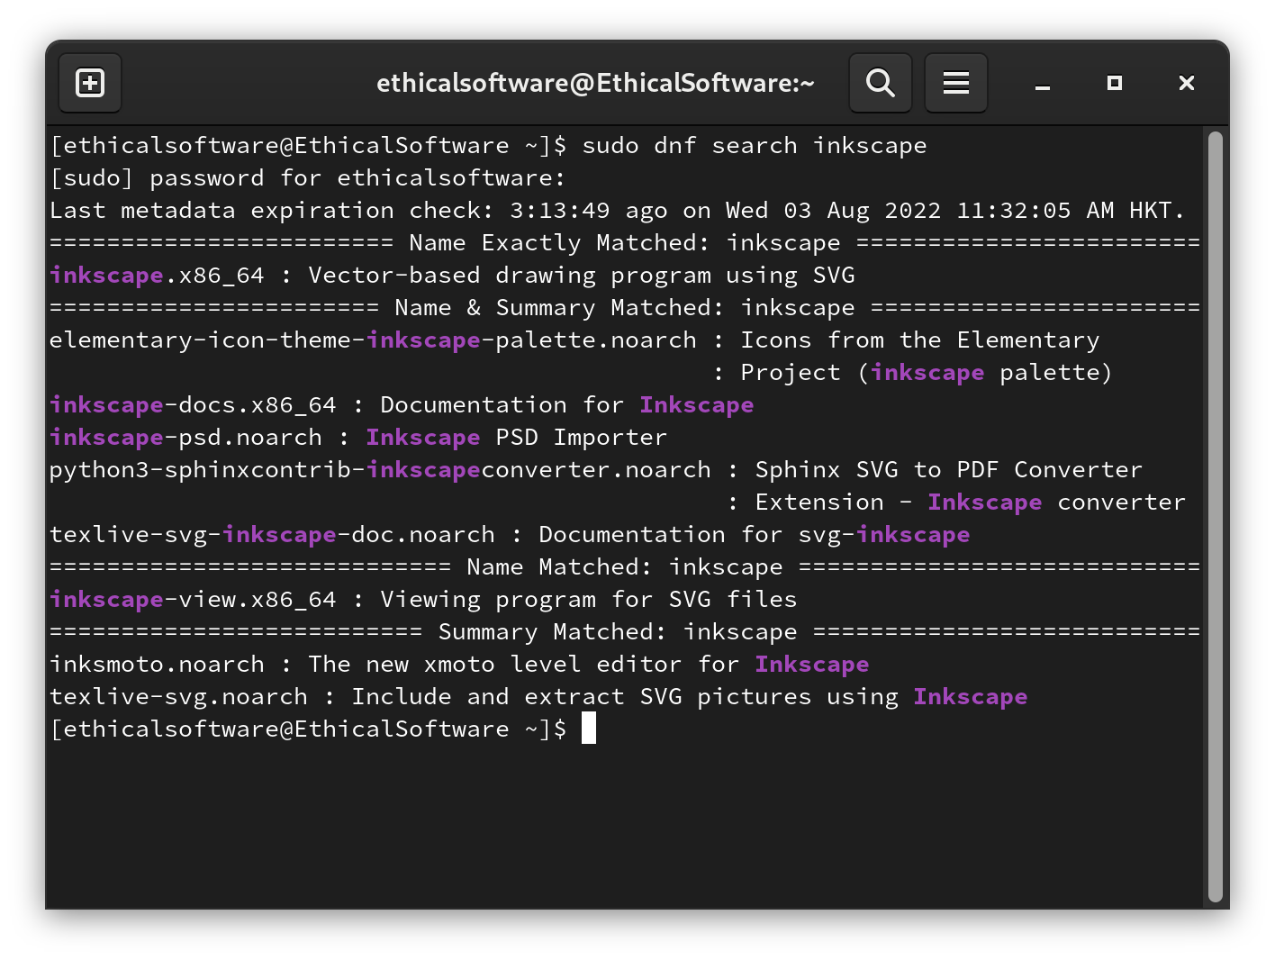
Step 6. As we found that there are “inkscape“packages available for install, we will execute the following command and begin to install “inkscape”.
sudo dnf install inkscape
After Entering the above command, type in the “y” key to confirm this installation.

Example Output:
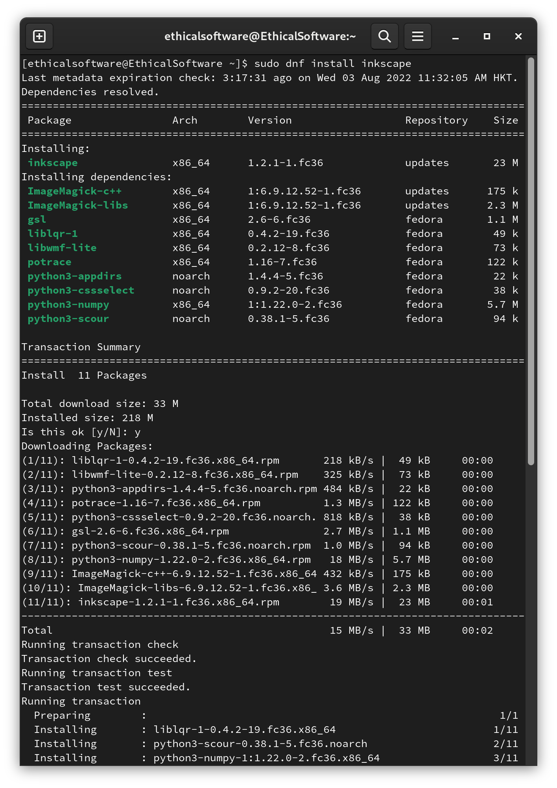
If no error message popped out, you are good to go and enjoy your package!

E.N.D

Updating Fedora
It is always good to update Fedora on a daily basis. In this tutorial, we will get to know how to update your Fedora System.

Option 1, via Terminal:

Step 1. First, on your Fedora, move your mouse to the top-left corner of your screen.
You should see the following screen:

Example Output:

Step 2. Left Click “Type to search”.

Example Output:
Step 3. Enter the word “Terminal”.

Example Output:

Step 4. After Left Clicking on the Terminal Icon. You should see the following terminal pop out.

Example Output:
Step 5. Enter the below command in the terminal to update your Fedora system release. Then, enter your user password:
sudo dnf upgrade --refresh
Example Output:
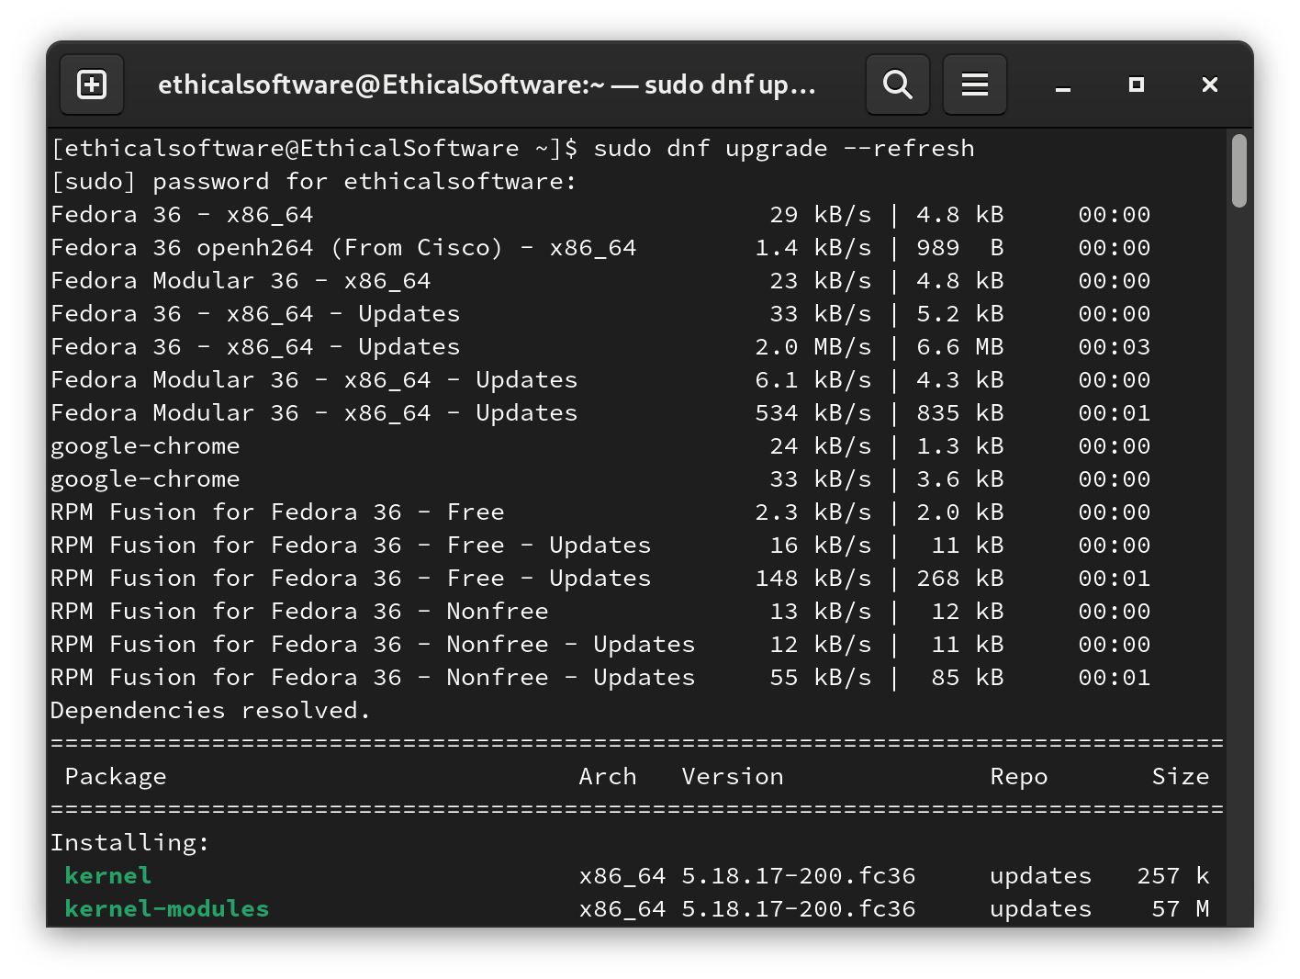
- Enter the key “y” and press enter to confirm this update. if you encountered more questions asking for [y/N], enter “y”.
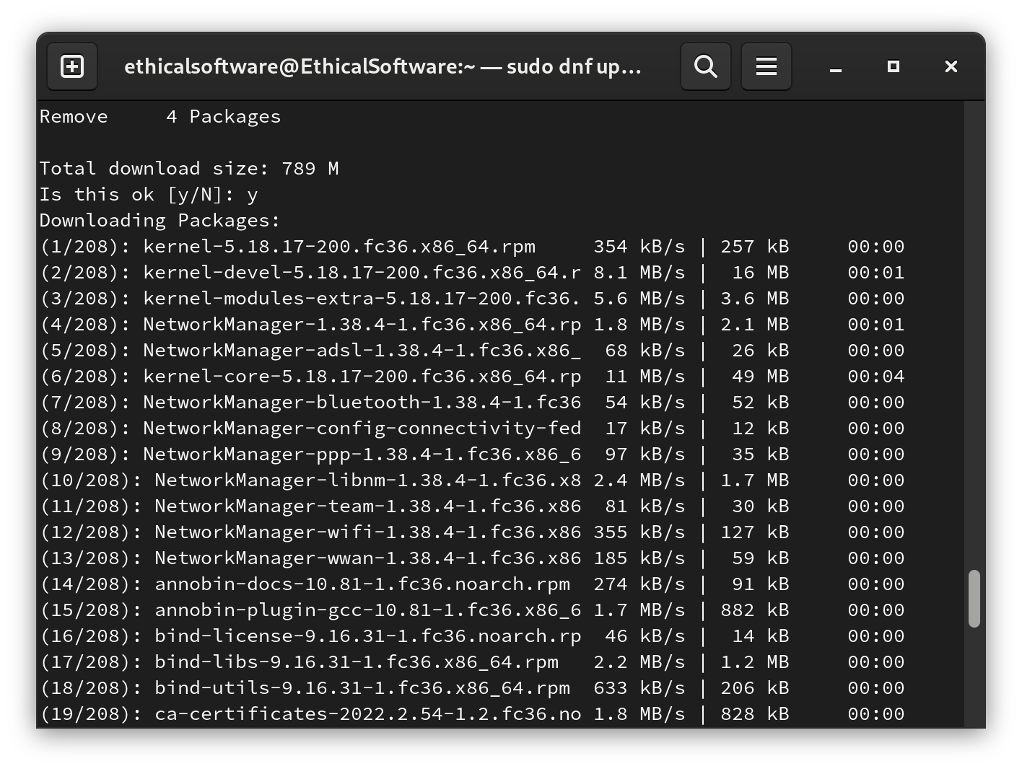
- If no error occurs, you are good to go.
Step 6. Reboot your PC.

* * *

Option 2, via Software Store:

Step 1. First, on your Fedora, move your mouse to the top-left corner of your screen.
You should see the following screen:

Example Output:
Step 2. Follow the Blue Arrow and Left Click on the “Software” app store Icon :

Example Output:
Step 3. You should see the following “Software” store screen and Left Click “Updates” as pointed by the red arrow.

Example Output:
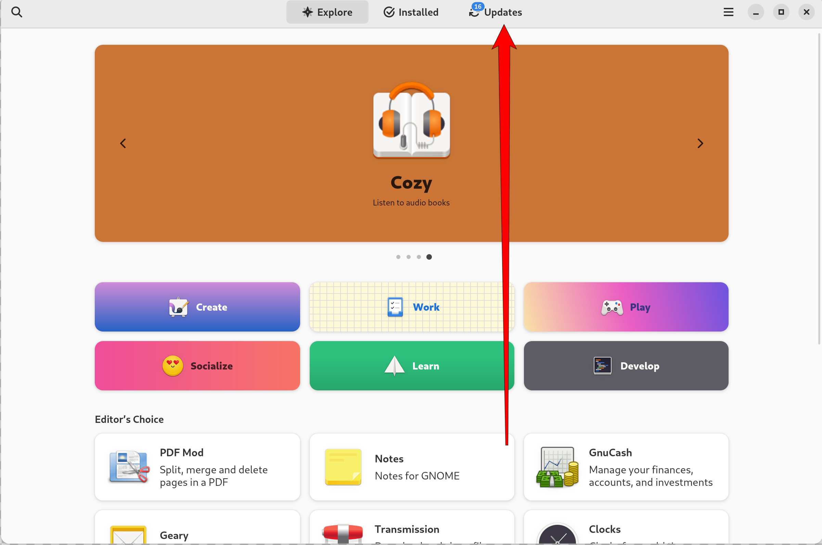
Step 4. Press the “Restart & Update” blue button to update Fedora!

Example Output:
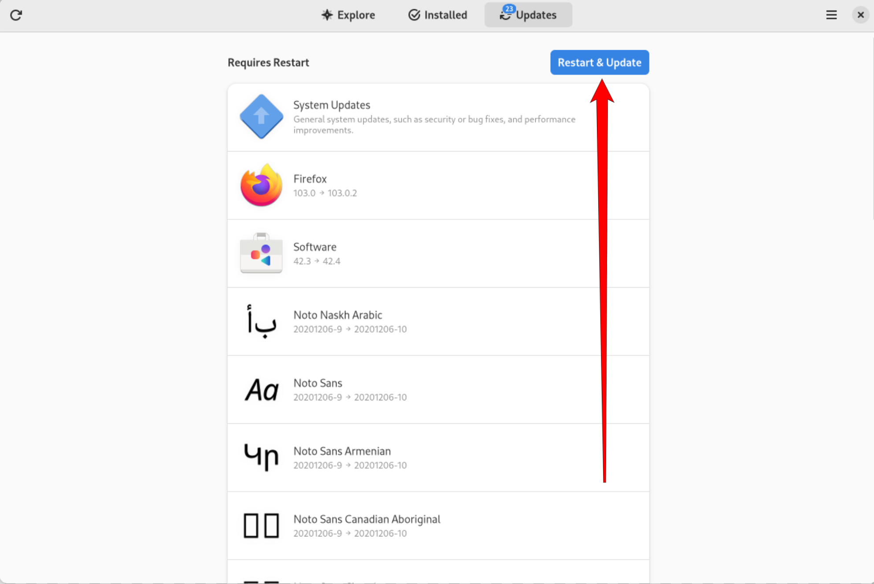
Step 5. Press the “Restart & install” confirm button!

Example Output:
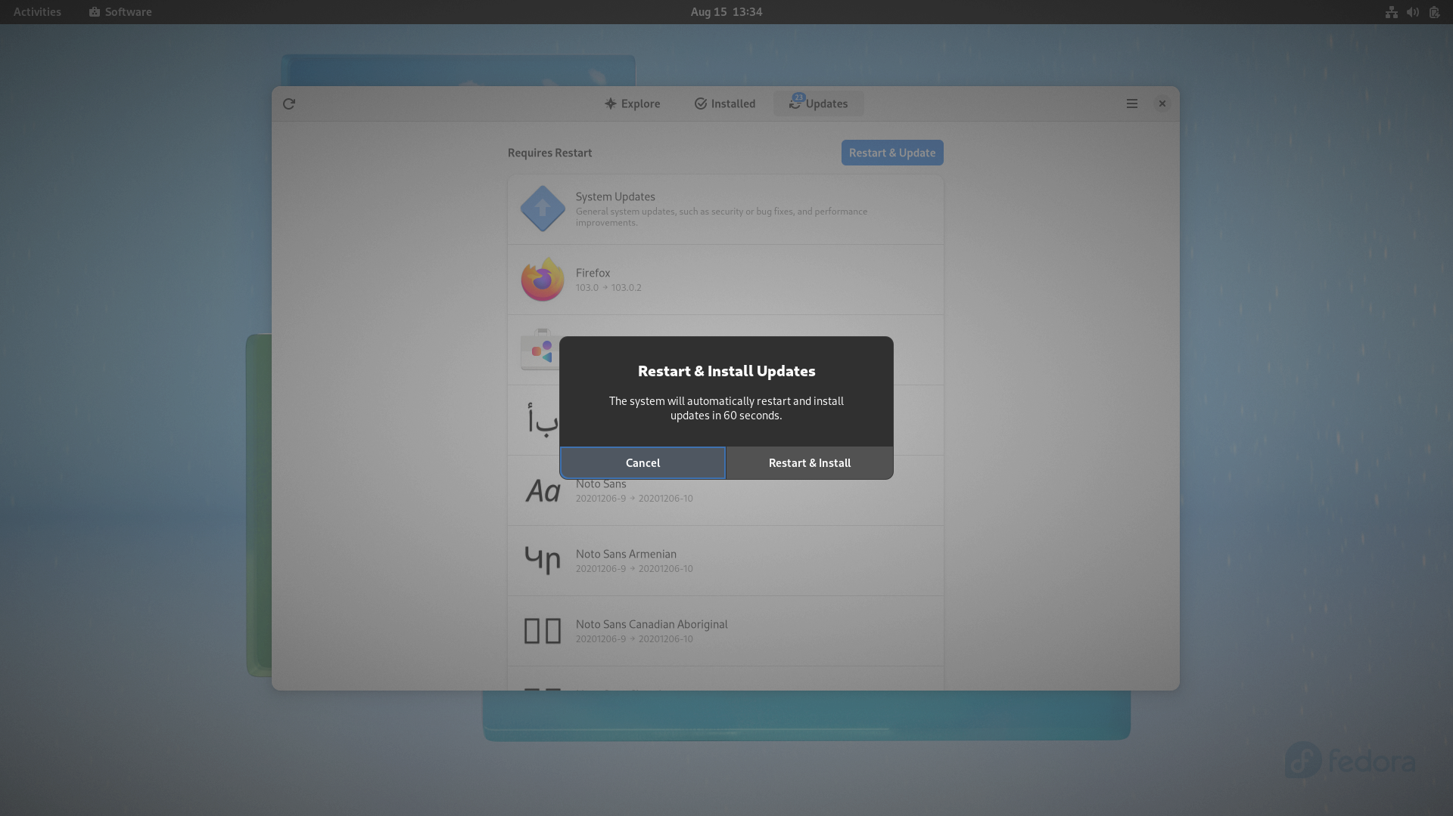
Now your Fedora System and software are up to date!

E.N.D

Terminal Basic
A terminal is a text input and output interface. It serves as a Linux program that allows us to enter commands for the computer to process.

Basic Commands
Color Formatting for the Commands
Command + Description
Use case
Example Output

1.
cd (Change Directory)
The cd command helped the user to change their current working directory. If we perform the following command, we could then change the directory to the Desktop directory.
cd Desktop/
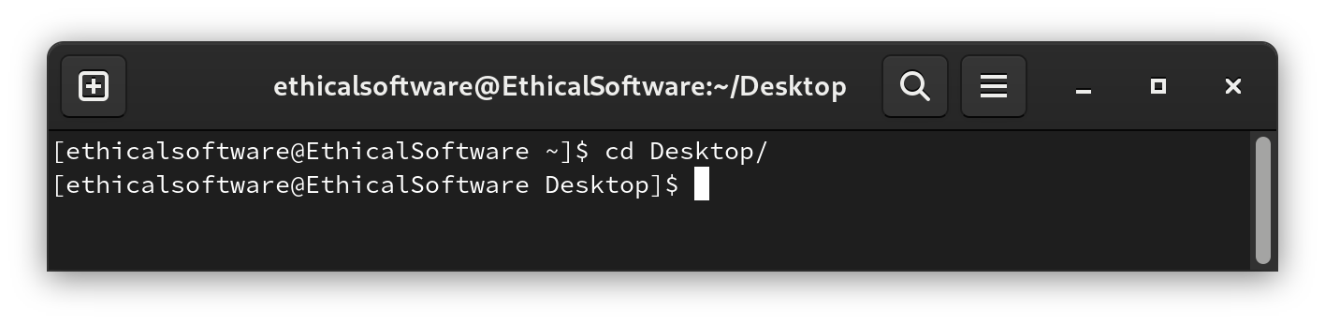

2.
ls (Listing Directory)
We could use ls to view the contents (files and directories) inside of the current director.In our case, we are listing the content inside our Desktop.
ls
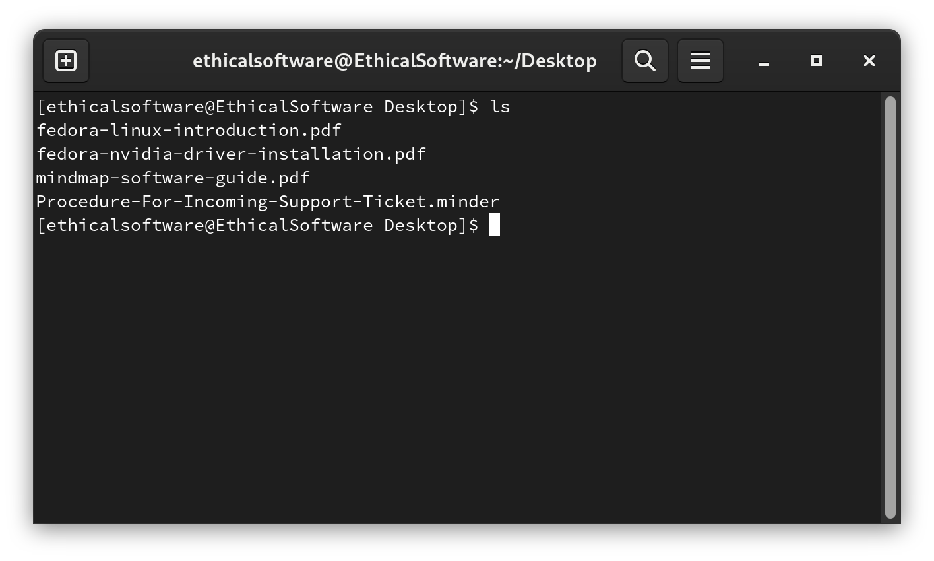

- in addition, if we would like to have more detail on the files, we could add the argument -l (ls -l).
ls -l
Example Output:
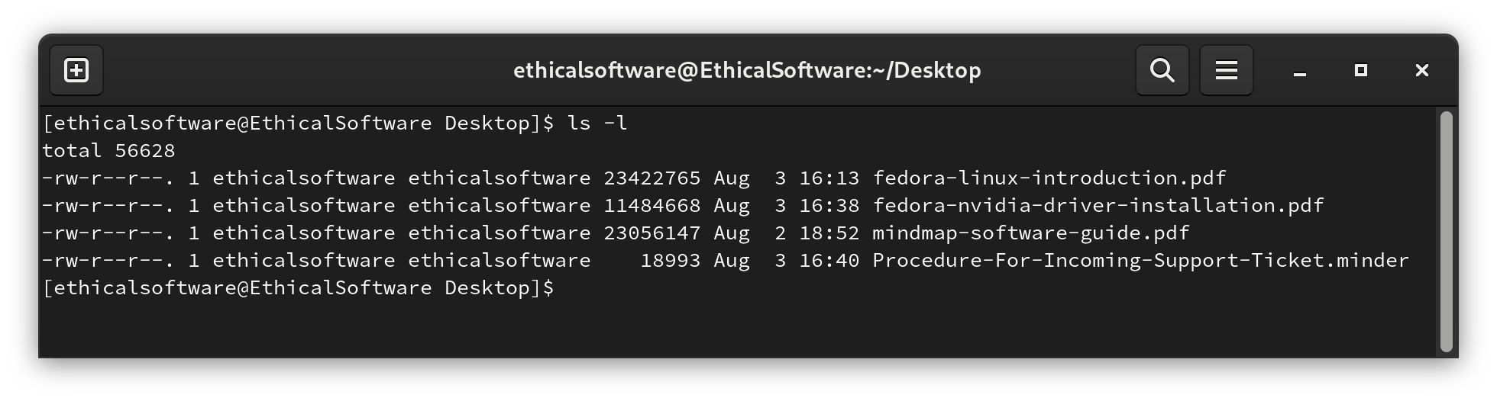
3.
xdg-open (Open files)
We might have a file we would like to open in the current directory; we could use the xdg-open command to open it. For example, I would like to open the “mindmap-software-guide.pdf” in the “Desktop” Directory.
xdg-open mindmap-software-guide.pdf
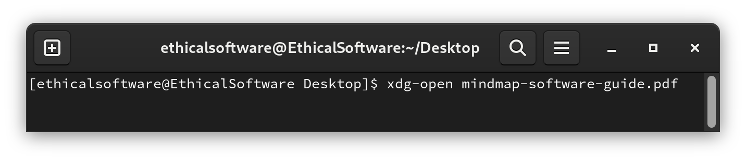

4.
cp (Copy a file to another directory)
The cp command aids us in copying a file from one location to another. Also, We have to follow the format (cp “filename” “newfilename”). As an example, we will copy the “mindmap-software-guide.pdf” to the “Download” Directory.
cp mindmap-software-guide.pdf ../Downloads/Copy_of_mindmap.pdf
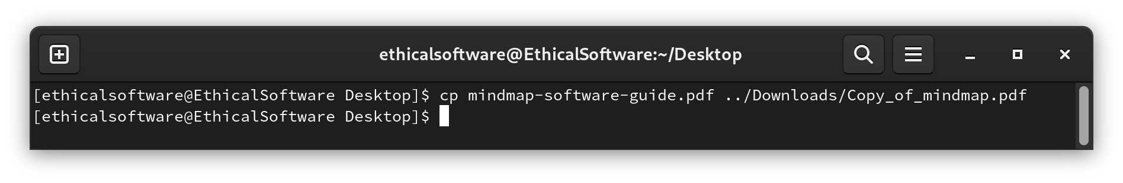

5.
mv (Move a file)
If we don’t want to copy a file but rather move it to another location, simply use the (mv “filename” “path/to/new/file/location”)
mv mindmap-software-guide.pdf ../Downloads/mindmap-software-guide.pdf
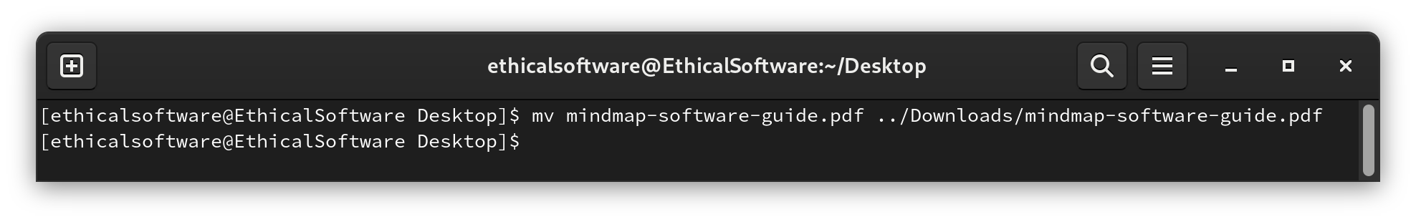

6.
touch (Create any file)
The touch command helps us in creating any type of blank file. After creating a blank file, we can edit it inside an editor (E.g. Text Editor).
touch myFirstFile.txt
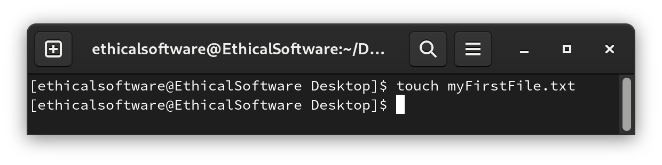

7.
mkdir (Create a directory)
If we need a place to store new files, just use the mkdir command to add a new directory in the current working directory. Moreover, a full path could also be specified if needed.
mkdir MyNewFolder
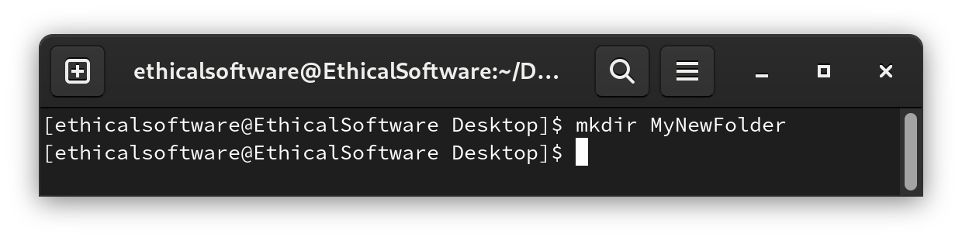

8.
rmdir (Remove an empty directory)
Sometimes we might want to remove the Folder we just created, mkdir
is a good command for removing that Folder.
rmdir MyNewFolder
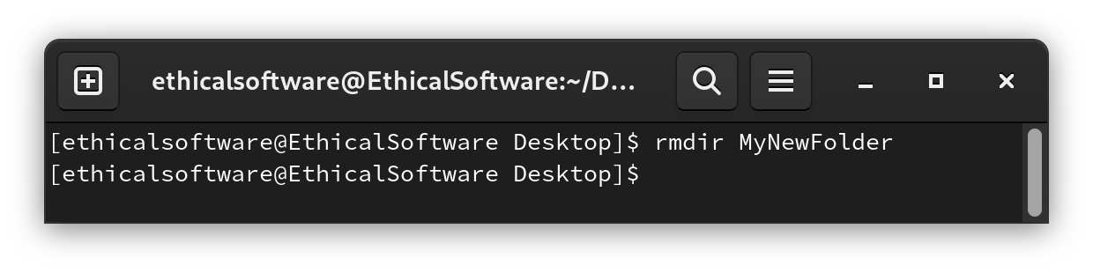

9.
rm -R (Remove nested directories)
On some occasions, we may want to delete a Folder that contains some other
files/subfolders, we could make use of the rm -R command to complete this task.
Bear in mind. This command is irreversible!!!
rm -R MyNewFolder
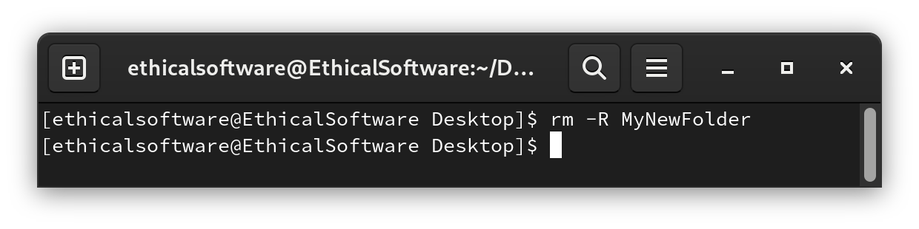

10.
sudo (Execute commands with superuser privileges)
The sudo command promotes your user privileges when executing the command requiring Admin rights. For instance, by using sudo, removing another user’s file could be performed.
sudo rm -R filesOfUser1
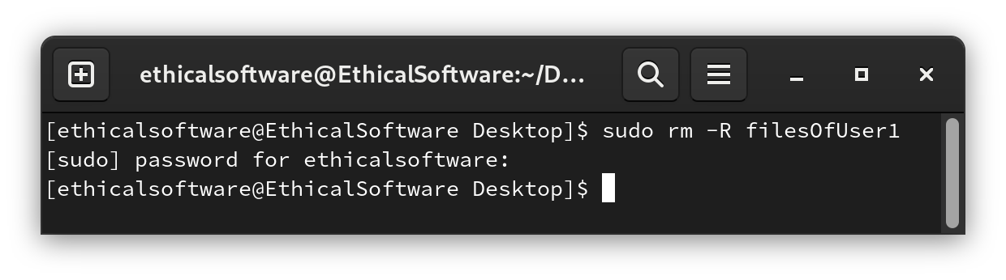

11.
top (List actively running computer processes)
System status could be reviewed under the top command, including RAM, CPU/GPU and disk utilization. Further, apps that take up a large amount of computer resources will be examined at the top.
(P.S. Press the “q” key to exit this screen)
top
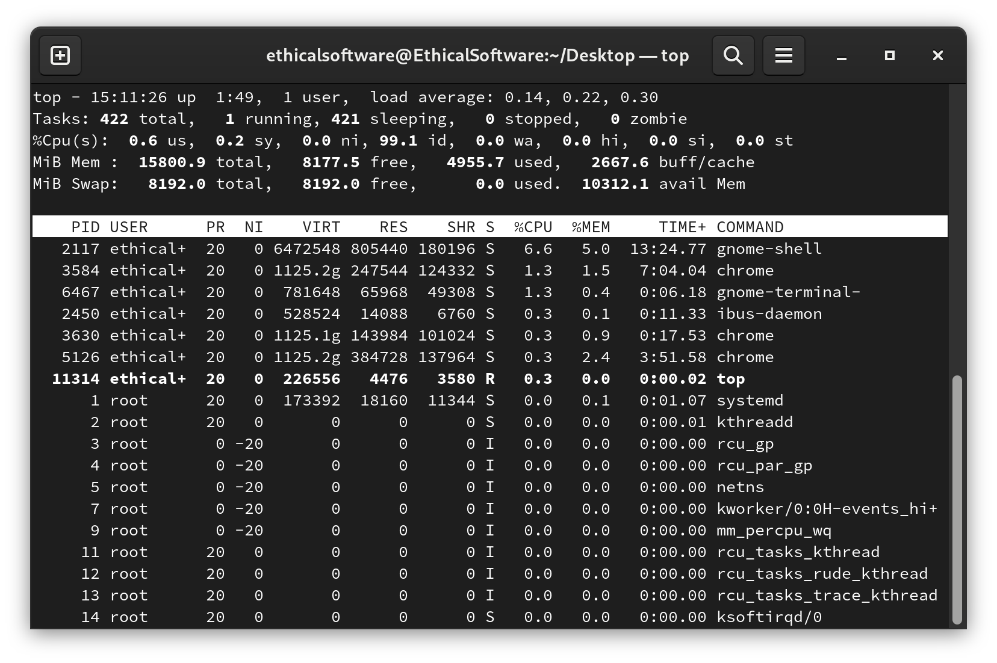
12.
q (Quit sub-screen and return to Terminal)
For a command like top that leads us to sunscreen, we can exit it by entering the q key in the terminal. If things go wrong with q, try “Ctrl + c” on the keyboard.
q
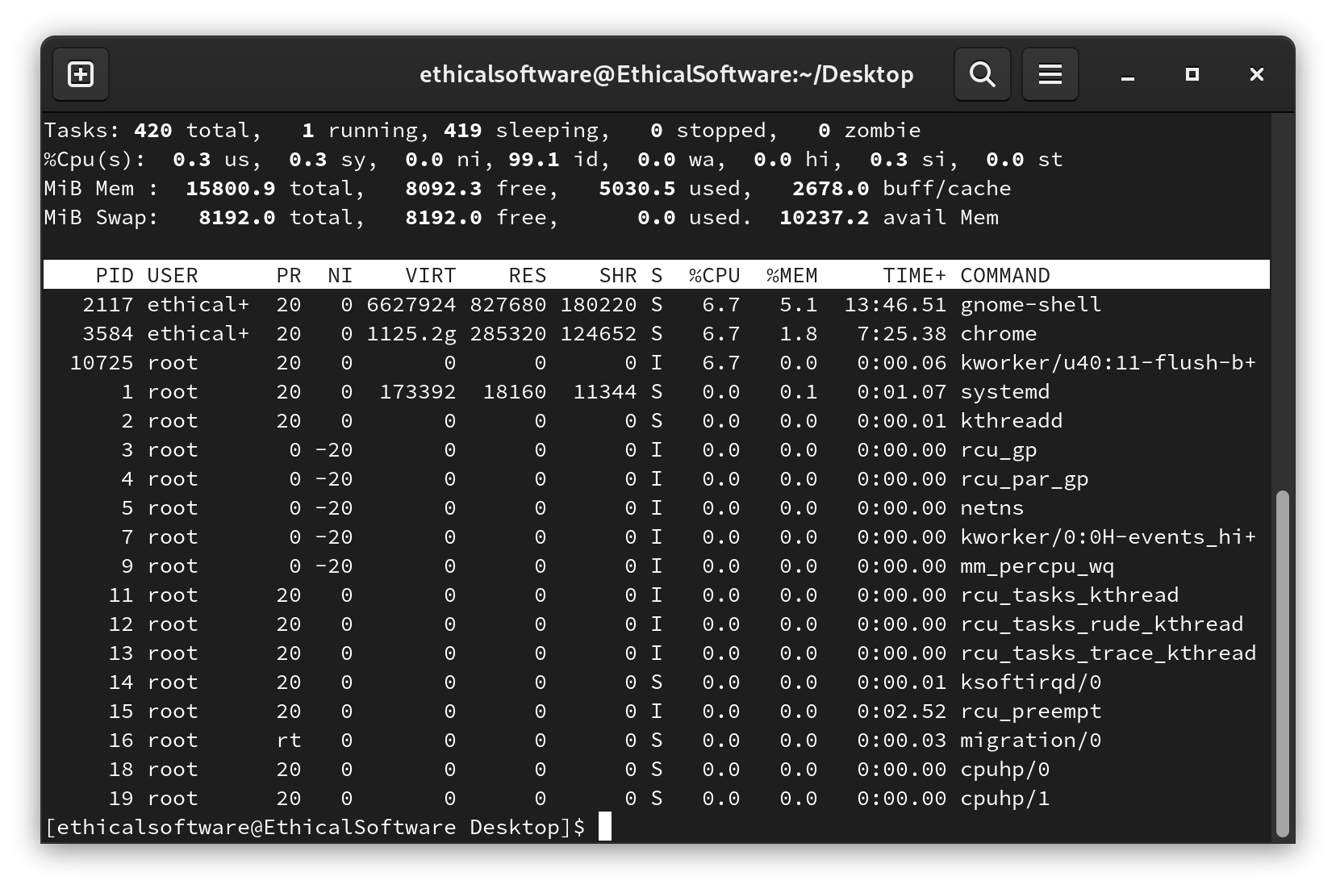

13.
clear (Clear the Terminal screen of all previous commands)
When the screen looks messy with thousands of things, we could use the clear command to remove all previously typed commands/History from the Terminal. Instead of entering the clear command, we can press Ctrl+L to perform the same action.
clear
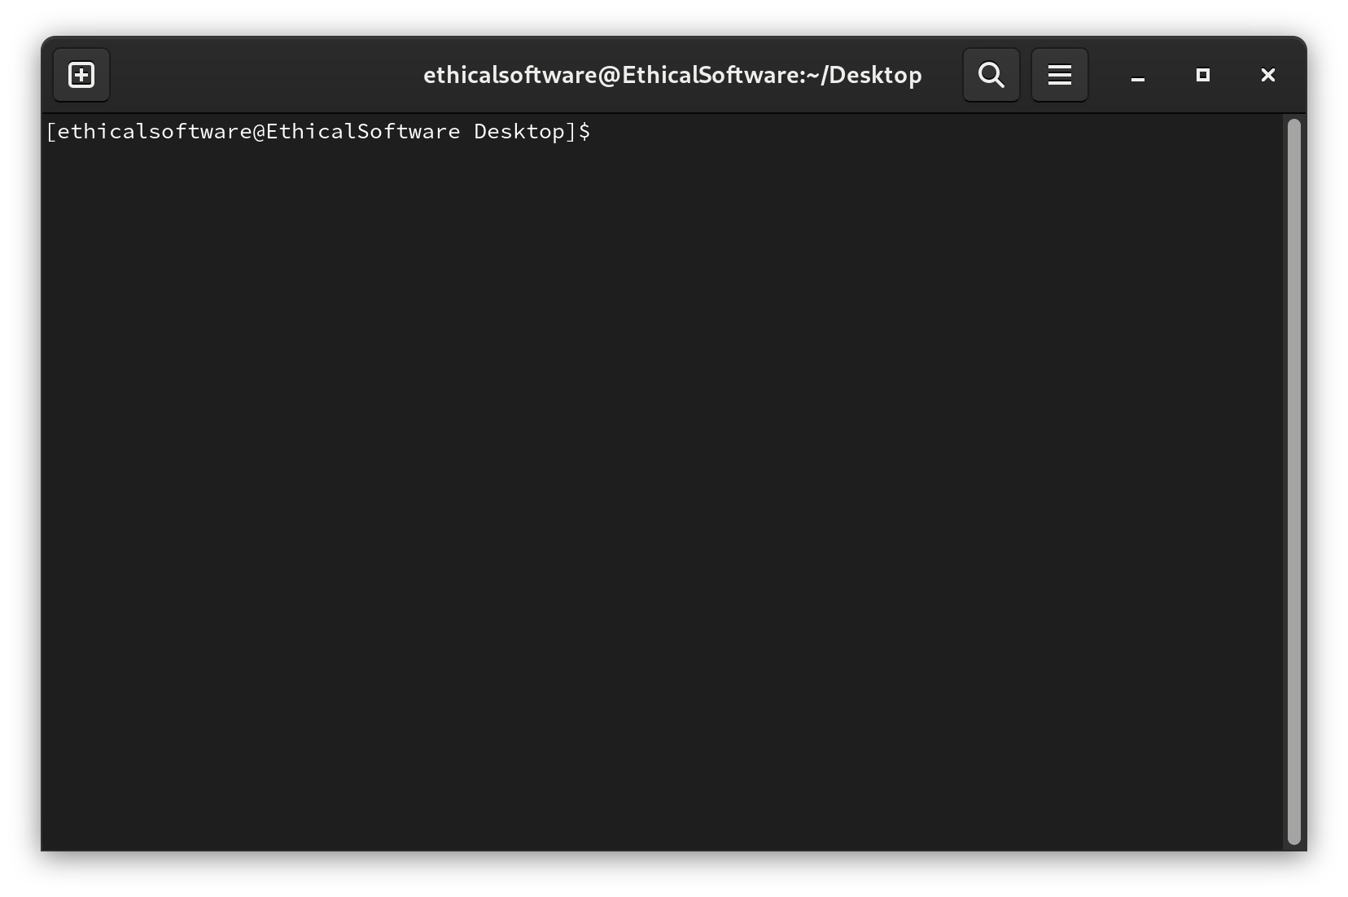

14.
whatis (Get one-line description for a command)
whatis helps in getting a short description of the command in Linux.
whatis ls
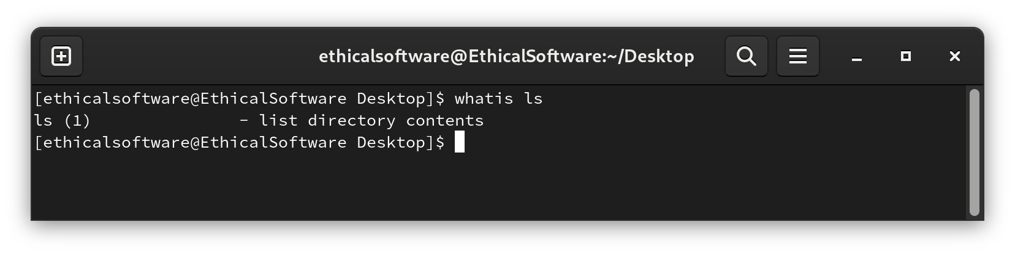

15.
man (Show manual page for a command)
Most command in the terminal comes with a manual, by using man command on a explicit command, we could look up the argument/information for that command.
man ls
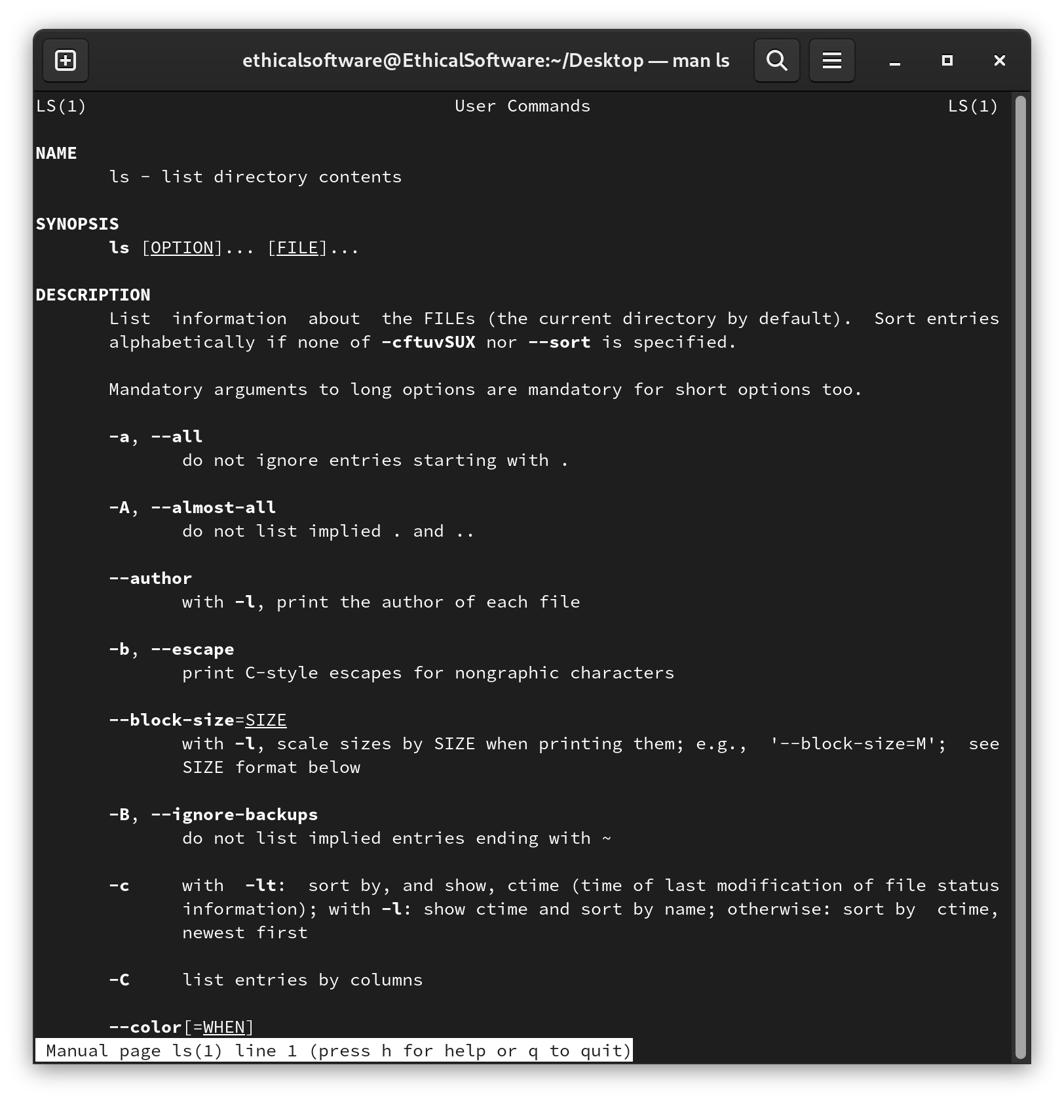

E.N.D

https://docs.fedoraproject.org/en-US/fedora/latest/install-guide
https://docs.fedoraproject.org/en-US/quick-docs/setup_rpmfusion/
https://docs.fedoraproject.org/en-US/quick-docs/dnf/

